Annex I.

A. Driving and reporting on sustainable implementation approaches

1. The UNOPS strategic plan, 2018-2021 establishes the UNOPS sustainable implementation approaches which the organization strives to embed in its activities to realize tangible impacts in its implementation projects. The embedding of sustainable implementation approaches is based on context and the nature of the activities performed, and the UNOPS standards management framework which provides tools and guidance on recognized practices.
2. This annex presents the initial steps in preparing a structured monitoring and reporting framework for assessing and demonstrating the effect of these approaches, particularly in implementation projects where UNOPS acts as a principal. The aim is to further enhance accountability and transparency of UNOPS performance and results in furtherance of its strategic goals through sustainable implementation. The approaches include measures for local and national capacity development, and comprise three mutually reinforcing dimensions of sustainability: (a) equitable economic growth; (b) social justice and inclusion; (c) environmental respect.

Enhanced focus on sustainable implementation
3. The introduction of a framework on sustainable implementation approaches enables the 2020-21 management results framework to renew its focus on performance indicators related to the four management goals, aligned around the UNOPS balanced scorecard perspectives (partners, people, process, and finance). This means that measures related to areas such as impact on local economies, capacity building, community engagement, and use of local suppliers will now be captured in a designated framework aimed at driving and promoting sustainable implementation approaches.

Global Reporting Initiative standards at the core
4. UNOPS already aligns its annual report to the Global Reporting Initiative (‘GRI’) – the sustainability reporting organization developed in collaboration with the United Nations Environment Programme and the United Nations Global Compact. To strengthen reporting on UNOPS sustainable practices, GRI standards and disclosures have been mainstreamed into the sustainability framework (see table 1), which is organized around economic, social and environmental (S2E) topics in line with the strategic plan, 2018-2021 and the GRI approach.
5. A structured and focused framework building on experience and current practices will enable the organization to systematically monitor and provide a focused account of the value it adds. Particularly, the contributions it makes to “help people achieve individual, local national and global objectives, through effective specialized technical expertise grounded in international norms and standards.”

Foundation for a sustainability framework
6. As this annex introduces the foundation for a reporting framework for sustainable implementation approaches, the framework will be further developed to support assessments in the midterm review of the UNOPS strategic plan, 2018-2021. Pursuant to the midterm review, it is envisaged that results achieved through sustainable implementation approaches will be reported on a regular basis through to the Annual report of the Executive Director.
7. In the table 1, ‘sustainable implementation approaches’ and ‘dimensions of sustainability’ are derived from the strategic plan, 2018-2021. The potential performance indicators are current examples of data on project activities collected primarily through annual sustainability reporting, and used for various reporting ends. The associated reporting standards have been included to illustrate mainly the link with the GRI approach. It is expected that measures for monitoring the effect of the sustainable implementation approaches will be subject to continuous improvement, in parallel with enhancements to the standards management framework and supporting ICT-enabled tools.

Table 1. Initial framework for monitoring and reporting on sustainable implementation approaches

Sustainable implementation approaches | Dimensions of sustainability | Performance indicators  (examples) | Reporting standards (examples)
a) Equitable economic growth | (i) Ensuring optimum value for money by pursuing effective management practices and investment strategies, upholding the principles of transparency and accountability, and considering appropriate exit strategies | · Number of labor days created for local (women) workers  · Share of procurement with registered local suppliers in developing and fragile states | · GRI 203-1: Infrastructure investments and services supported  · GRI 204-1: Proportion of spending on local suppliers
 | (ii) Supporting livelihoods through expanded market access and use of local workforces and suppliers wherever possible, including opportunities for women- and youth-owned businesses
 | (iii) Considering the total cost of ownership (financing, operating, maintaining and replacing assets)
b) Social justice and inclusion | (i) Exercising due diligence, respect for human rights and rights-based approaches, and advancing gender equality and empowerment of women and girls throughout implementation projects | · Share of projects implementing capacity building for women and youth in project delivery  · Share of projects with local community engagement  · Share of projects enabling equal access and use by women, minority groups and persons with disabilities | · GRI 203-2: Significant indirect economic impacts  · GRI 413-1: Operations with local community engagement, impact assessments, and development programs  · GRI NGO4: Measures to integrate gender and diversity into program design and implementation
 | (ii) Engaging local communities and beneficiaries and ensuring equitable access to project benefits, with particular emphasis on protecting the most vulnerable
 | (iii) Facilitating access to food, water, sanitation, energy, health, education, justice and security-related services
c) Environmental respect | (i) Mitigating adverse impact on the environment and improving biodiversity and ecological resilience | · Share of offices successfully maintaining ISO 14001 certification  · Share of energy consumption from renewable energy sources | · ISO 14001: Environmental management systems  · GRI 302-1: Energy consumption within the organization
 | (ii) Using renewable resources, taking into account the interactions between human development and environmental sustainability
 | (iii) Increasing the resilience of countries and communities to withstand the shocks of natural disasters

B. UNOPS global functions
8. UNOPS has developed its budget for the biennium 2020-2021 in alignment with the harmonized approach adopted by UNDP, UNFPA and UNICEF based on decisions 2010/32, 2011/10, 2012/27 and 2013/9, in which the Executive Board approved harmonized approaches for cost classification, results-based budgeting and budget presentation. The harmonized approach includes presentation of the budget in line with seven harmonized functional clusters. In continuation of the budget estimates for the biennium 2012-2013 to 2018-2019, UNOPS deploys a more granular functional framework internally and describes 14 global functions traceable to the seven harmonized functional clusters:
Figure 1: UNOPS global functions mapped to harmonized functional clusters
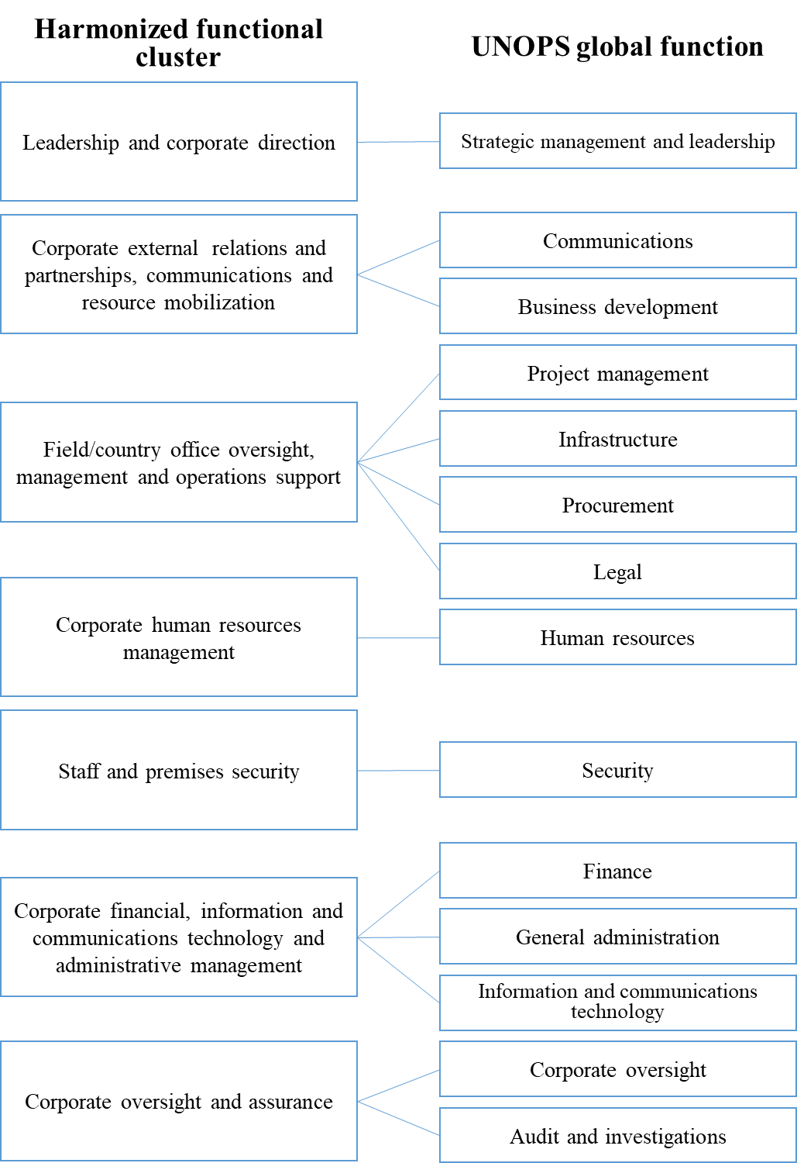

Strategic management and leadership
9. The global function ‘Strategic management and leadership’ includes responsibility to:
(a) Develop, champion and act as a role model for the UNOPS mission, vision, values and ethics;
(b) Set strategy based on understanding the needs and expectations of stakeholders and the external environment, and on an understanding of internal performance capabilities;
(c) Provide strategic direction and authoritative advice on corporate priorities and ensure appropriate structural arrangements within and between entities in the global structure;
(d) Oversee organizational and/or project portfolio performance, and execute appropriate controls;
(e) Advise on development, review and updating of relevant policies;
(f) Advise on implementation, communication and monitoring of relevant policies;
(g) Engage with external stakeholders, including United Nations coordination.

Project management
10. The global function ‘project management’ includes responsibility to:
(a) Enable timely delivery of successful projects and programmes in accordance with the UNOPS project management methodology, which ensures that quality, speed and results are of the highest standards;
(b) Advance project management practices, including through the use of tools for community engagement, integration of gender equality; and contribute to national capacity development;
(c) Identify and develop opportunities for the provision of project management services for partners;
(d) Support project management as the primary modality of delivery for UNOPS, externally and internally;
(e) Enable and distribute efficient and effective provision of support and advice to users and external partners, while ensuring adequate controls;
(f) Within the field of project management, provide and deliver best practice examples, tools, guidance and oversight of projects and project portfolios.

Infrastructure
11. The global function ‘Infrastructure’ includes responsibility to:
(a) Enable timely delivery of successful infrastructure projects in which the quality, speed and results are of the highest standards;
(b) Advance infrastructure practices, including through integrating resilience and climate change adaption elements, and contribute to national capacity development;
(c) Identify and develop opportunities for the provision of infrastructure services for partners;
(d) Ensure that the organization’s products and services are developed to create optimum value for partners and beneficiaries and are produced, delivered and managed using sustainable approaches;
(e) Enable and distribute efficient, effective provision of support and advice to users and external partners, while ensuring adequate controls;
(f) Within the field of infrastructure, provide and deliver best practice examples, tools, guidance and oversight of infrastructure projects.
Procurement
12. The global function ‘Procurement’ includes responsibility to:
(a) Enable the organization to procure goods and services in a transparent, accountable and efficient manner in order to execute the UNOPS business strategy;
(b) Advance procurement practices, including through sourcing strategies chains and considerations of product life-cycles, and contribute to national capacity development;
(c) Identify and develop opportunities for the provision of procurement services for partners;
(d) Ensure that UNOPS products and services are developed to create optimum value for partners and beneficiaries, and are produced, delivered and managed using sustainable approaches;
(e) Enable and distribute efficient, effective support and advice to users and external partners, while ensuring adequate controls;
(f) Within the field of procurement, provide and deliver best practice examples, tools, guidance and oversight of procurement and procurement projects.

Communications
13. The global function ‘Communications’ includes responsibility to:
(a) Develop communications strategies, policies, plans and channels based on communications needs and expectations;
(b) Maintain and strengthen the UNOPS corporate identity through unifying internal and external communications, enabling accountability and transparency;
(c) Communicate clear direction and strategic focus, ensuring that the people of UNOPS understand and can demonstrate their contribution to its success;
(d) Facilitate and encourage the sharing of information, knowledge and best practices, achieving dialogue throughout the organization.

Business development
14. The global function ‘Business development’ includes responsibility to:
(a) Establish and deepen strategic partnerships in support of the development of new engagements, and facilitate coordinated, systematic approaches to business partner and client relations management, for mutual, sustainable benefit;
(b) Ensure greater collaboration and coordination with key partners, including through the establishment of liaison offices to engage on current projects and future priorities, and for knowledge-sharing;
(c) Ensure that UNOPS products and services are promoted and marketed effectively, and that partner relationships are managed and strengthened;
(d) Manage UNOPS knowledge partners for sustainable benefits for the organization and its partners;
(e) Within the field of business development, provide and deliver best practice examples, tools, guidance and oversight of partner relations and engagements.
Finance
15. The global function ‘Finance’ includes responsibility to:
(a) Steward the resources of the organization, ensuring cost recovery, financial resilience and accurate financial reporting to partners and clients;
(b) Advance development effectiveness, including through further attribution of direct cost for shared services as appropriate;
(c) Maintain appropriate controls and integrity of financial management, in accordance with relevant international standards;
(d) Enable and distribute efficient, effective support and advice to users and external partners, while ensuring adequate controls (in reporting, for example);
(e) Within the field of finance, provide and deliver best practice examples, tools, guidance and oversight of finance processes.
(f) Ensure effective and efficient planning of management budget and results
(g) Maintain appropriate review mechanism for financial and non-financial results, on quarterly and annual basis

Human resources
16. The global function ‘Human resources’ includes responsibility to:
(a) Enable UNOPS to recruit, develop and retain a talented workforce with the skills and competencies to execute its business strategy;
(b) Ensure that UNOPS personnel are aligned, including through linking standardized profiles and job descriptions to organizational structures, processes and products and services;
(c) Promote a culture that allows the mutually beneficial achievement of organizational and personnel goals, by caring, communicating, rewarding and recognizing, in a way that motivates UNOPS people, builds commitment, and enables them to use their skills and knowledge for the benefit of the organization;
(d) Promote fairness, equality and diversity, including gender parity;
(e) Enable and distribute efficient and effective provision of support and advice to users and external partners while ensuring adequate controls (with regards to individual contractor agreements, for example);
(f) Within the field of human resources, provide and deliver best practice examples, tools, guidance and oversight of human resources processes.
(g) Drive and support world-class performance and continuous improvement, and nurture a high-performance management culture, ensuring that the organization is flexible and manages change effectively; add risk
(h) Advise on and drive cross-functional integration and coordination within the organization;

Legal
17. The global function ‘Legal’ includes responsibility to:
(a) Enable the UNOPS legal and contracting activities to execute its business strategy, ensuring that its legal commitments reflect the UNOPS vision, values and ethics;
(b) Enable and distribute efficient, effective support and advice to users and external partners, while ensuring adequate controls.

General administration
18. The corporate function ‘General administration’ includes responsibility to:
(a) Facilitate the provision of premises, facilities and support services that are functional, cost-effective and sustainable;
(b) Optimize the use, and effectively manage the life-cycle and physical security, of buildings, equipment and materials;
(c) Establish safe, timely and cost-effective travel arrangements;
(d) Establish and implement realistic, effective and efficient business continuity and disaster recovery plans;
(e) Establish and implement policy for records retention and management;
(f) Facilitate host country liaison.

Information and communications technology
19. The corporate function ‘Information and communications technology’ includes responsibility to:
(a) Manage information and communications technology to support the delivery of UNOPS strategy;
(b) Manage the technology portfolio by optimizing use of existing technology and replacing outdated technology;
(c) Evaluate and develop the technology portfolio to improve the agility of UNOPS and its processes and projects;
(d) Involve relevant stakeholders in the development and deployment of new technologies to maximize benefits generated;
(e) Use technology to support the UNOPS culture of creativity and innovation;
(f) Aid and advise on transforming data into information, and facilitate distribution of timely, accurate, strategic and tactical management decision support.

Security
20. The global function ‘Security’ includes responsibility to:
(a) Provide UNOPS internal entities with advice, guidance and technical assistance regarding health, safety, environmental and security throughout its global responsibilities;
(b) Consistently provide managers and personnel with the necessary information and tools concerning the day-to-day management of health, safety, environmental and security risks;
(c) Provide instructions to support health, safety, environmental and security decision-making and to escalate decisions with regional or organization-wide impact to the Executive Director;
(d) Strengthen and make more explicit the overall safety and security framework, culture, and roles and responsibilities within the organization to allow justified, measured approaches and responses to health, safety, environmental and security management practices globally.

Corporate Oversight
21. The global function ‘Corporate Oversight’ includes responsibility to:
(a) Ensure that UNOPS is able to gather and aggregate risk related information at all organisational levels
(b) Ensure that UNOPS projects are regularly assessed against cost and time targets
(c) Ensure that proposed procurement actions are in accordance with UNOPS financial regulations and rules, policies, and instructions;
(d) Review the procurement process to ensure that it is fair, competitive, and transparent, provides best value for money, and represents best practices and commonly accepted practices of United Nations procurement.

Audit and investigations
22. The corporate function ‘Audit and investigations’ includes responsibility to:
(a) Provide independent, impartial assurance and advice designed to improve UNOPS operations;
(b) Lead the Executive Director’s investigations into alleged fraud, corruption, waste of resources, abuse of authority or other misconduct or violations of UNOPS regulations, rules and administrative instructions;
(c) Help the organization achieve its objectives through a systematic approach designed to evaluate and enhance the effectiveness of risk management, control and governance processes.

C. Comparison of original and final budget for the biennium 2016-2017

23. UNBOA has recommended that UNOPS obtain post facto approval of the Executive Board on original and final budget including each line item. The approval is requested for the latest biennium for which Financial Statements certified by the UNBOA are available.
24. The following table presents the comparison of original and final budget for the biennium 2016-2017, and explanation of material variance by line item. For the biennium, the variances are in general a reflection of the need to adapt the organization to the increased demand of UNOPS services by partners.

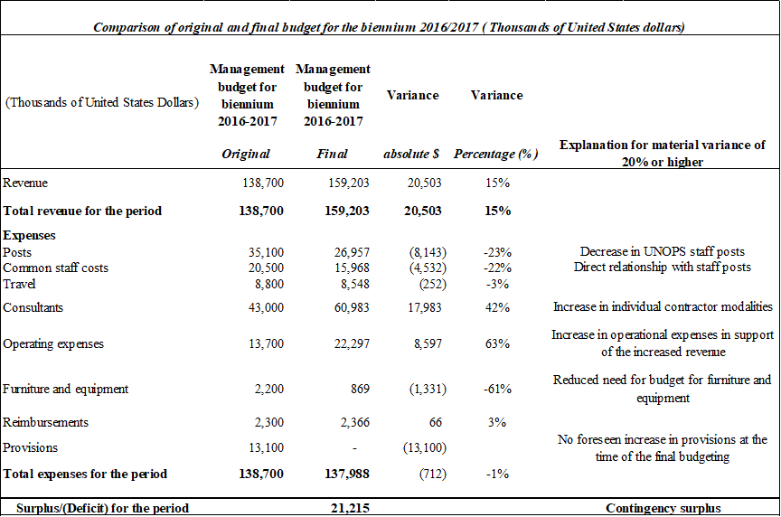

25. UNOPS will continue to keep both the Executive Board and the UNBOA informed regarding the original and final budgets and related material changes through the annual Financial Statements. Related annexes were introduced from 2017 UNOPS Financial Statements.

D. Terminology

Activity-based costing: Cost accounting method that identifies activties in an organization and assigns organizational cost based on the resource consumption of the different activities.
Advisory services: Contributing to increased national capacity and ownership through advice to partners on best management practices, standards, systems and processes, and related training, in UNOPS-mandated focus areas.
Global function: An area of specialized expertise within UNOPS. The totality of personnel associated with a global function is refered to as a practice, which transcends entities in global structure of the organization. All the practices are insititutionally anchored at UNOPS headquarters.
Cost driver: In activity-based costing, activities that affect costs are defined as ‘cost drivers’. UNOPS uses cost drivers as fair proxy to link costs charged to resource consumption.
Cost increase/decrease: Any increase or decrease in the cost of a resource input in the budget period compared with that in the previous budget period, arising from inflation and changes in exchange rates.
Delivery platform: The ability to serve partners through the integration of existing processes, information and communications technology systems, and locations. The delivery platform, as backbone to UNOPS activities, seeks to achieve scale, cost savings, and the global reach of UNOPS activities without replicating operational setups in each location where UNOPS is active.
Delivery or delivery volume: Project expenditure, excluding fees.
Direct cost: Costs incurred for the benefit of a particular project or client(s). Such costs are readily identifiable as having direct benefit for a particular project or client(s), and can be clearly documented. Direct costs are not covered by the management fee.
Enterprise resource planning: A management information system that integrates and automates business practices associated with the operations of an organization; or multi-module application software that helps an organization to support such systems; or a combination of the above.
Harmonized functional cluster: Part of the harmonized approach adopted by UNDP, UNFPA and UNICEF in which UNOPS submits its budget estimates. UNOPS global functions can be mapped to the seven harmonized functional clusters.
Indirect cost: Costs incurred by the management and administration of the organization in furtherance of UNOPS activities and policies. Such costs are charged to projects through a management fee specified in the project agreement.
Individual contractor agreement (known as an ‘ICA’): A UNOPS legal instrument governed solely by its expressed terms and conditions, including the terms of reference and general conditions for such agreements as determined by UNOPS policy. The individual contractor agreement is used to retain the services of a person engaged in his/her individual capacity to perform a specific task or deliver a defined piece of work within specific project-based deliverables of time-limited nature.
Key Performance indicator (KPI): A quantitative expression of level of ambition, providing a gauge for the extent to which a goal is achieved. A performance indicator is typically expressed with a baseline (performance at the beginning of a given period) and a target (level of ambition for performance at the end of that period). The indications of results achieved at a given point in time are typically referred to as ‘actuals’. Results derived from performance against an indicator may express the extent to which a quantiative goal is achieved, or be used to substantiate a qualitative expression of goal achievement.
Liabilities: All present commitments of UNOPS arising from past events, the settlement of which is expected to result in an outflow from UNOPS of resources embodying economic benefits or service potential.
Management budget/resources: UNOPS budget estimates in support of the management results framework, that is, budget estimates excluding net revenue target and earmarking for potential provisions.
Management results: The UNOPS management results framework is based on its four management goals: partner value; people excellence; process excellence; and financial stewardship. The four management goals provide direction to how UNOPS ensures the viability of its self-financing business model, and reflect the four perspectives (partners; people; process; and finance) of the UNOPS balanced scorecard, a core management tool used to drive performance and maturity at all levels of the organization by means of performance indicators and associated targets.
Net revenue: The difference between gross revenue and expenses.
Net surplus/deficit: Comprises the following components: (a) surplus or deficit from ordinary activities; and (b) extraordinary items.
Operational reserves: The reserve established at the level set by the Executive Board with the aim of guaranteeing the financial viability and integrity of UNOPS as a going concern.
Self-financing: Generating its capital from its own revenue, instead of acquiring it from external sources.
Transactional support services: Specific services, in the United Nations context typically associated with common or shared services, where partners avail themselves of the UNOPS delivery platform. These services are limited to identifiable, specific transactions in areas such as procurement and human resources.
Volume increase/decrease: Any increase or decrease in resource requirements attributable to changes in the level or nature of activities carried out by an organization during the current budget period and those proposed for the forthcoming budget period.
Write-offs or writing off: The cancellation of a bad debt or worthless asset from a UNOPS account or project account; the act of cancelling such a debt or asset.

______________

DP/OPS/2017/5, paragraphs 16 and 17
DP/OPS/2019/5, table 1
DP/OPS/2017/5, paragraph 54.b

