Annex 4

UNDP Strategic Plan 2018-2021

Theory of Change
Table of Contents:
I. Introduction and overview
II. Strategic Plan Outcome 1
III. Strategic Plan Outcome 2
IV. Strategic Plan Outcome 3

- Introduction and overview

- The UNDP Strategic Plan and Theory of Change
To help countries to achieve sustainable development by eradicating poverty in all its forms and dimensions, and accelerate structural transformations for sustainable development and building resilience to crises and shocks, the Strategic Plan describes how UNDP will support programme countries in achieving the 2030 Agenda and Sustainable Development Goals (SDGs) and fulfill commitments under related agreements, and international legal and normative frameworks. It will tailor support to specific development contexts and needs, across the 170 countries and territories where UNDP works.
The Strategic Plan is framed around the following components:
- Three broad development settings or development outcomes.
- Six signature solutions that define UNDP core areas of work across three development settings and that embody 27 development outputs.
- Two delivery platforms, including a country support platform for the SDGs and global development advisory and implementation services platform to deliver integrated solutions.
- An improved business model delivers the Strategic Plan through performance and innovation streams.
Figure 1: An integrated offer: three development settings (outcomes) and six signature solutions
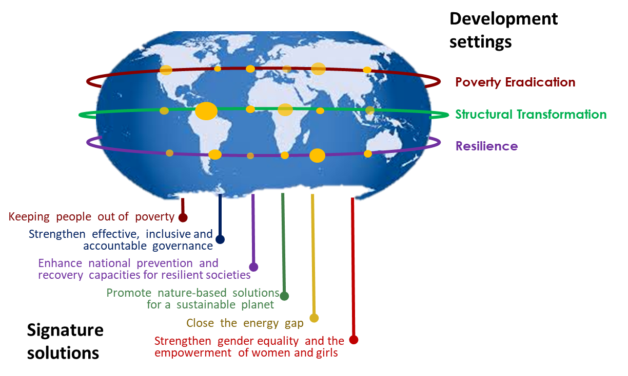
Underpinning the UNDP Strategic Plan is a Theory of Change (ToC) that articulates strategies, approaches and interventions that, when implemented successfully along envisaged causal ‘development pathways’, will lead to the achievement of Strategic Plan results. All UNDP interventions contribute to a development output, which contribute toward one or more of the three development outcomes of the UNDP Strategic Plan:
- Outcome 1: Eradicate poverty in all its forms and dimensions;
- Outcome 2: Accelerate structural transformations for sustainable development; and,
- Outcome 3: Build resilience to shocks and crises.

The ToC provides the basis for the UNDP Strategic Plan Integrated Results and Resources Framework (IRRF) and guides the design, implementation, monitoring and reporting of UNDP programming, thereby strengthening its accountability for the delivery of results.
While this unique offer is elaborated in six signature solutions and 27 development outputs, UNDP works with other United Nations (UN) system including specialized agencies towards achieving the SDGs, based on its mandate and collaborative advantage. In particular, UNDP works closely with sister agencies on common results, as elaborated in the Common Chapter of the Strategic Plans of UNDP, UNICEF, UNFPA and UN Women. Moreover, joint analysis, planning, and delivery will be monitored as per the QCPR indicators incorporated into the IRRF Tier Three indicators, and joint programming aligned with priority areas identified in the System Wide Strategic Document (SWSD) once refined.
This ToC paper articulates how UNDP programme and project interventions have been designed to lead to specific results within and across development contexts, as well as across country typologies and sectors. It highlights the multi-sectoral approach of UNDP and its role as “integrator” working to bring together primary stakeholders and partners in development -including governments, regional entities, civil society, academia, private sector, international financial institutions (IFIs), and the United Nations Development System (UNDS). Outlined in this document are assumptions and risks that may positively and negatively affect the ability of UNDP to deliver envisaged results according to development pathways.
The ToC is a living framework that responds to the emerging and evolving needs of countries and partners. Over the course of implementing the Strategic Plan for 2018-2021, UNDP will continuously monitor how change takes place since development pathways may require modification and re-calibration once the effectiveness and efficiencies of interventions are assessed. Assumptions will be monitored, validated or adjusted based on data and evidence, risks will be continuously identified, mitigated, monitored and managed, and emerging issues will affect adjustments to programme and project design and implementation strategies. UNDP will utilize the ToC as a tool to apply lessons learned to future programming.

Figure 2: 3 Strategic Plan Results Architecture: 3 Outcomes, 27 Outputs embodied within 6 cross-cutting Signature Solutions
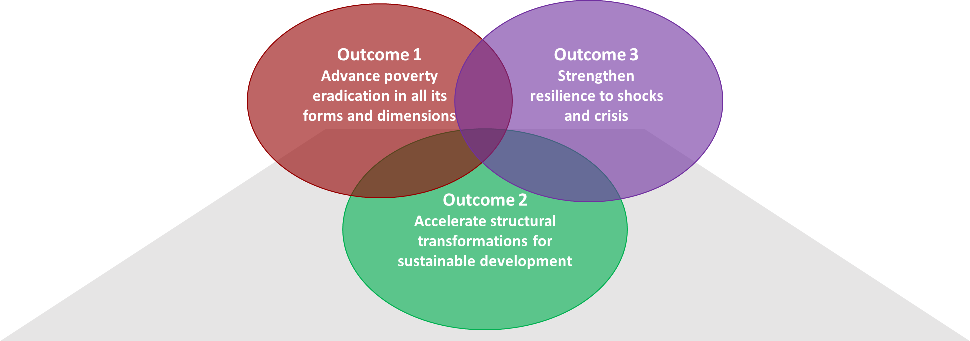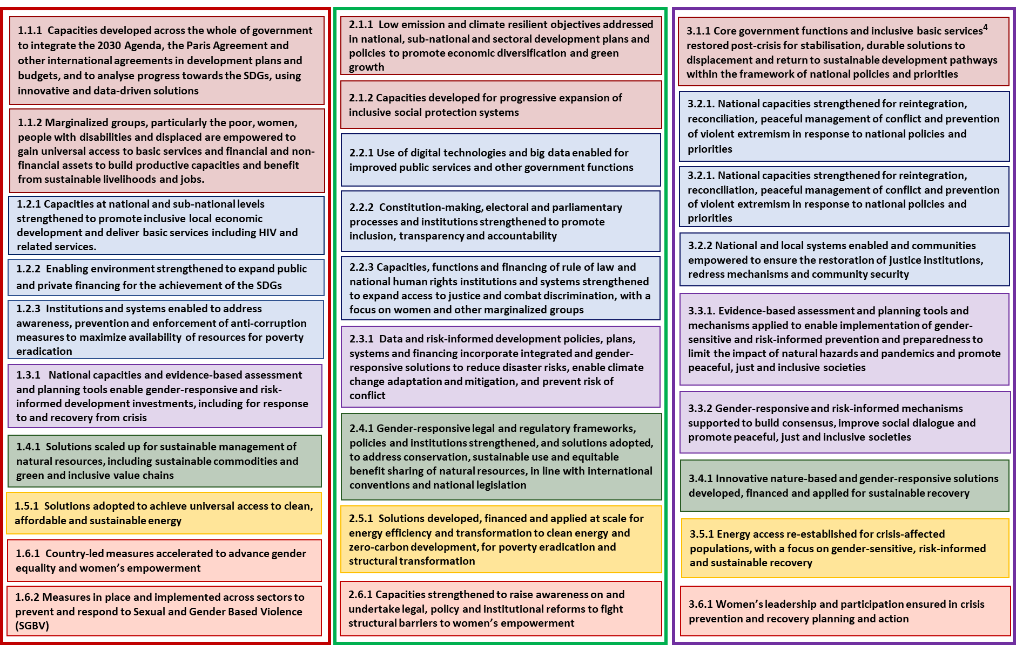

- The UNDP Strategic Plan and the 2030 Agenda
The UNDP Strategic Plan sets out an organizational vision of support to countries in achieving the 2030 Agenda, SDGs, and related agreements. The shift from the Millennium Development Goals (MDGs) to the 2030 Agenda introduced important implications for development cooperation that heavily informed UNDP direction, underlying principles, and areas of work for the next four years. Recommendations from the Evaluation of the Strategic Plan 2014-2017, and accompanying UNDP management responses, reaffirmed UNDP commitment to the ambitious aims of the 2030 Agenda, while also informing the development of the new Strategic Plan.
As the 2030 Agenda goes beyond the poverty-centric focus of the MDGs—taking into full consideration the need for economic, social and environmental sustainability—it has resulted in a wide range of aspirations: from sustainable modes of production and consumption to peaceful and inclusive societies. The breadth of the SDGs demands UNDP move beyond silos and take an integrated approach to development interventions by thinking through connections and looking for synergies and/or dividends across various areas of work.

The Evaluation of the UNDP Strategic Plan, Global and Regional Programmes noted that UNDP’s increasingly integrated, multifaceted approach to development challenges is well suited to, and consistent with, United Nations priorities and the needs of national partners.

UNDP as integrator: As per the Secretary General’s Report, “UNDP’s comprehensive mandate and track-record on multidimensional poverty, capacity development and institutional strengthening, positions it as a vehicle to support an integrated, multi-sectoral and multi-stakeholder approach.” UNDP’s designated role as an ‘integrator platform’ reaffirms the following recommendation made in the evaluation of the UNDP Strategic Plan: “Support for fulfilment of the SDGs should be a cross-cutting issue for all UNDP country offices, and integrated approaches to development are essential for fulfilment of the Goals and should be pursued where possible, taking national contexts and implementation efficiencies into consideration.”
Harnessing collaborative advantages and expertise of respective UN agencies, funds and programmes is paramount to designing and implementing integrated solutions. “Repositioned as the integrator platform at the heart of a new generation of country teams, UNDP assets and expertise should be placed at the service of the wider development system through the leadership of the resident coordinator.” UNDP will continue to work across line ministries and with diverse development partners to promote ‘whole-of-government’ and ‘whole-of-society’ responses that are vital for transformational change and achieving the SDGs.
Leaving no one behind: Leaving no one behind (LNOB) is the central, transformative promise of the 2030 Agenda for Sustainable Development and Sustainable Development Goals (SDGs). It represents the commitment of all United Nations Member States to eradicate poverty in all its forms, end discrimination and exclusion, and reduce the inequalities and vulnerabilities that leave people behind. The draft UNDAF guidelines on LNOB identifies five factors: discrimination based on assumed or ascribed identity; vulnerability to shocks; inadequate governance and legal frameworks; socio-economic status including inequalities, and the geography of where one lives. The principles and strategic objectives of “leaving no one behind” and “reaching the furthest behind first” cuts across the UNDP Strategic Plan and results framework. It includes ambitious targets that aim to benefit the most marginalized and vulnerable groups. Specific vulnerable groups for each development context are elaborated in ‘target groups’ section under each development outcome.
Beyond and across borders: The universality of the 2030 Agenda (where goals apply to all countries in the world) requires a rigorous approach to address shared challenges and solutions—within and across countries, regions and around the world—that go beyond national policy-making to result in more international collective action. Shared challenges include the need to address the health of the climate and oceans in the face of shrinking planetary boundaries, and where collective action on global public goods requires coherent and effective cooperation between countries. Through systematic support to South-South and triangular cooperation (especially where UNDP acts as a knowledge broker, capacity developer or partnership facilitator) UNDP will explore effective approaches and ways to bring about positive development trajectories, “relying more heavily on country programming as an efficient way to leverage South-South at the national level”.
Risk-informed development: The adoption of the 2030 Agenda recognized that development cannot be thought of as a linear process, and there are many risks factors that influence development trajectories. This necessitates a deeper understanding of the root causes of vulnerability and their complex economic, social and political dynamics, as well as interactions between people and their environments. Development pathway across all Strategic Plan outcomes require three things. The first are risk-informed approaches to adequately meet the needs of the most vulnerable, curb the drivers of risk, and prevent people from falling back into poverty due to crisis and shocks. The second are risk-informed mechanisms that build consensus, improve social dialogues, prevent risk of conflict and promote peaceful, just and inclusive societies. The third are risk-informed development policies, plans systems and financing that reduce disaster risks, enable climate change adaptation and mitigation, and limit the fallout from pandemics.

- Sustainable development pathways: from challenges to solutions
Context-specific development challenges: Guided by the integrative approach embodied in the 2030 Agenda, UNDP will collaborate with national governments and partners to follow sustainable development pathways across three broad but connected development settings. This includes supporting: 1) countries/regions that strive to fulfill basic development needs (which may have addressed some fundamental development needs and still working to overcome others), 2) countries/regions that seek to accelerate structural transformations required to sustain progress (e.g. some middle-income countries, despite economic growth, remain vulnerable to economic shocks), and 3) countries/regions at any stage of the development trajectory that need to build resilience and response capacities in the face of shocks and crises (whether it be natural disaster or conflict).
Tackling shared root causes: Recognizing that challenges are not mutually exclusive, embedded in the ToC is the need to identify shared root and structural causes, their complex economic, environmental, social and political dynamics, as well as the nature of interactions between populations and their habitats. For example, across the three development contexts, UNDP recognizes that shared root and structural causes exist that may be economic in nature, such as globalization and its effects on the poor and most vulnerable, or lack of financial incentives for the private sector to invest in nature-based solutions or recovery. There are also shared social and political causes, where inequality is perpetuated through societal structures—such as gender stereotypes and governance systems that marginalize certain population groups and exclude them from development processes. Structural or root causes that are environmental in nature include the transgression of planetary boundaries and risks that disproportionately affect poor and disadvantaged groups.
Lack of sufficient financing is recognized across the outcome ToCs as a common obstacle to achieving development results. Challenges facing middle-income countries may be fundamentally different from the financing environment in a developing country, and warrant new sources and blending of financing. The role of the private sector in moving towards more inclusive and sustainable business models, without undermining profitability, is also critical for achieving the SDGs. Supporting the implementation of the Addis Ababa Action Agenda is a common thread within UNDP approaches as it provides a global framework for financing sustainable development by aligning financing flows and policies with economic, social and environmental priorities.
Across the three development settings, women and girls face particular vulnerabilities, discriminatory practices and attitudes. These include gender-based violence including sexual violence, deep rooted discriminatory cultural and social practices that perpetuate gender inequalities, limit economic opportunities and exclude them from political processes, and regulatory and legal frameworks and policies that are not sufficiently gender-responsive. Mainstreaming gender and women’s empowerment across all Strategic Plan development outcomes, while supporting stand-alone gender interventions, reflect UNDP’s commitment “toward a more robust gender architecture, stronger accountability mechanisms, budgetary commitments and reporting targets” . Implementation of these aims will be reinforced through the UNDP Gender Equality Strategy and commitments to the United Nations System-Wide Action Plan (UNSWAP) on Gender and the Empowerment of Women, under which strengthened partnerships with UN-Women and other technical partners will be key to delivering gender results across all programming areas.
Another shared challenge across the three outcomes is the lack of credible and disaggregated data (including big data) and evidence to inform interventions, solutions and policy development along the development pathway. This is a significant challenge, particularly as it is critical to identifying the most marginalised and vulnerable and delivering on UNDP’s commitment to leave no one behind across all development settings. It is also one of the thematic priorities in the common chapter of the Strategic Plan.
Signature solutions tailored to development contexts: UNDP has proven knowledge and expertise in ensuring that: people who move out of poverty do not slide back; governance is effective, accountable, and inclusive; societies are more resilient through better prevention and recovery; the planet is more sustainable due to the adoption of nature-based solutions; clean and affordable energy is more accessible and energy gaps are closed, and there is greater gender equality and empowerment of women and girls. Programme countries have recognized this as reflected in the demand for UNDP services around the world.
While these are global signature services, the unique value of UNDP lies in its ability to draw on the experiences of its work across programme countries, and tailor development solutions by combining or configuring them to the specific context across the outcomes. Signature solutions connect outputs across outcome areas, demonstrating how certain interventions may vary depending on geography or time in a country’s trajectory, while being part of the overall solutions package.

Programmatic and organisational enablers, accelerators, and inhibiters
In designing interventions, UNDP will work with national partners and UN organizations to analyse who is left farthest behind, using tools like the UNDG operational guide on ‘Leaving No One Behind’, and identifying “catalytic policy and/or programme areas or accelerators that can trigger positive multiplier effects across the SDGs and targets.” Solutions will be developed to address bottlenecks that inhibit progress in the area, which will be implemented through combination and sequencing that is most effective in making accelerated progress on a number of fronts.
UNDP recognizes that addressing complex and integrated development challenges requires bringing together knowledge and expertise from within UNDS and beyond. Whether it is in the capacity of integrator, service provider or implementing partner, the commitment to working in collaboration with partners and development stakeholders, is evident across all ToCs. UNDP will continue to identify and develop strategic partnerships while broadening and deepening existing ones by working jointly towards mutually agreed-upon results, utilizing innovative ways to share costs and risks, drawing on instruments and tools, and employing safeguards that ensure the accountability of performance.
Tackling complex issues in a rapidly changing environment requires innovation and identifying new and more effective approaches and solutions such as: unlocking financing to achieve the SDGs; employing behavioral change and insight models to better diagnose development problems. UNDP will invest in pilots that test alternative ways of addressing development problems, find the best solutions based on evidence, and scale up successful innovations.
One of the hallmarks of the Strategic Plan are country support platforms, which will help rethink how UNDP and other partners support countries to address systemic or structural challenges in sustainable development – “wicked problems” – that would otherwise remain unresolved. This approach is driven by the realization that dealing with twenty-first century development ambitions and issues will require a substantial update of development cooperation, with much greater emphasis on openness, collaborative networks, innovation and scale of effort, among others. Country support platforms, therefore, represent a major departure from current ways of working. They recognize that the complex development issues at the heart of the 2030 Agenda require approaches that are much more open – in design, management and partnership – than traditional, project-based, development assistance. Platforms demand more inclusive forms of governance, management and participation, as well as skills that are still in relatively limited supply: for foresight, systems thinking, applied innovation, partnership-building and new forms of financing.

Organizationally, two streams of work will accelerate the delivery of programmatic support to countries: performance and innovation. The former focuses on ensuring that the UNDP business model is continuously modified to be as cost-efficient and effective as possible. The latter generates and tests new approaches on how UNDP delivers support, including developing new financial and legal instruments, and continuously strengthening staff capacities on new and integrated approaches. The two will reinforce each other, with innovation contributing to greater efficiencies and effectiveness, and improved efficiency and effectiveness that drives innovation.
In order to improve performance,engage with diverse partners in more innovative ways, and promote a culture where results and evidence are used for continuous organizational learning and toward informing strategic decisions, UNDP has completed an end-to-end review and re-write of programming approaches and requirements. More flexible choices are provided to work with diverse partners, including the private sector and IFIs. The introduction and expansion of programming instruments include: Development Services to help partners achieve development results; Engagement Facility to test innovations and help respond quickly to crisis, and Multi-Country projects to facilitate cross-border results.

Within the ToC are assumptions that are outcome-specific and cut across all outcomes. These assumptions relate to causality (‘if/then’ logic whereby planned interventions lead to intended change), implementation (e.g. UNDP operating space and/or security situation allows access), and other external and internal factors that influence UNDP areas of work and ability to deliver. These include, country commitment to the 2030 Agenda; governments as duty bearers respect, protect and guarantee the rights of all people; recognition of gender equality, women’s empowerment and participation as a development accelerator, and investments in data generation and collection are worthwhile and lead to policy formulation driven by evidence and data rather than political motivations. Additionally, another shared assumption is that political will exists to address policy reform, structural inequality, exclusion or discrimination, and sectoral bottlenecks in local or national contexts. Assumptions will be revisited and/or validated over the course of the Strategic Plan period.
Working on complex development challenges also comes with risks that are present across various development settings. If there is insufficient political support to address issues of structural inequality, exclusion or discrimination, interventions aimed at strengthening engagement and participation across all segments of society will be ineffective. Cultural and religious value systems may influence overarching political agendas and negatively affect the advancement of the gender equality. If vested interests and elitism drive a country’s agenda, the rights of all people may be unfulfilled and threatened. Lack of resources to invest in sustainable development efforts is a common inhibiter in all development contexts. Large scale shocks and crisis—manmade and natural—may severely prevent interventions from having lasting and positive effects. Risk management will be undertaken at the project, programme and corporate levels and take into consideration external and internal risks that hamper the realization of results.
UNDP will continue to cultivate a culture within the organization that enables responsible risk-taking and risk-informed decision-making, thereby fostering opportunity management, foresight and innovation rather than an approach that focuses only on avoiding harm.

- Outcome 1: Eradicate poverty in all its forms and dimensions

- Development challenges and causes
Around the world more than 650 million people live below the international poverty line ($1.90 US dollars per day) and 800 million people sit close to the threshold. All are vulnerable to social, economic and environmental shocks that can push them into poverty. When considering overlapping and multiple deprivations that individuals face—such as the 1 billion people who lack access to electricity—the figures are staggering: a total of 1.45 billion people are considered to be multi-dimensionally poor. Therefore, the contexts in which poverty is concentrated becomes important.
The majority of the world’s poor are women, and live in middle income countries in urban settings. Nearly 1.6 billion people live in countries affected by fragility and repeated cycles of violence and conflict—this includes approximately half of the world’s poor. In recent years, climate change and extreme weather events have exacerbated tensions and conflict, and have negatively affected the availability of natural resources, livelihoods and food security for millions of people. The number of people affected by disasters has doubled from 102 million in 2015 to 204 million in 2016 (UNOCHA).
In order to “leave no one behind,” it is important to look at inequalities and poverty. In 2014, the top 1 per cent of the global population held 48 per cent of the world’s wealth and is projected to own 54 per cent of the world’s wealth in 2020. The 2030 Agenda pushes government institutions to provide integrated and multi-dimensional responses to development challenges, from poverty eradication to human rights aspirations, yet, financing for development to meet the SDGs, eradicate poverty, and “leave no one behind” is insufficient and fragmented. In some cases, costs related to high levels of corruption, lack of transparency, and diversion of resources from development efforts amounts to 17 per cent of a country’s GDP. As a result, many governments are unable to meet the basic needs of populations. They cannot integrate development priorities in planning and budgeting, and produce risk-informed and gender-sensitive investments because of low capacities, and weak institutions and governance. Lack of incentives for the sustainable management of natural resources, policy incoherence, and limited financial services for small and medium enterprise (SME) development that boost green growth threaten the ability of governments to eradicate poverty because the world’s poor are disproportionately dependent on the environment for their livelihoods.
Poverty and inequality are perpetuated through political, economic, social structures, laws and norms, and governance systems that marginalize population groups and exclude them from political processes. Around the world, women and girls are systematically prevented from meeting their full potential, excluded from economic opportunities, and are vulnerable to gender-based violence, including sexual violence. Women constitute nearly 65 per cent of all people above retirement age but do not receive a regular pension, which places them at an increased risk of falling into poverty and or succumbing to a disability or prolonged illness. Poor communities, indigenous people, ethnic and linguistic minorities, people with disabilities, migrants, gender and sexual minorities, youth and the elderly are disproportionately among those left behind because they have inadequate access to basic services, including HIV medical care and related assistance, financial and non-financial resources, or productive assets.
Over a billion people have risen above the $1.90 US dollar/day poverty line since 1990. However, the risk of ‘falling back’ into poverty is a real threat to development. One out of six people who made it out of poverty “fall back in” because of political crises, natural hazards, illness or economic downturns. Natural hazards force 26 million people into poverty every year and over 100 million people could fall below the poverty line without rapid and inclusive development approaches that integrate climate action. Every year, 150 million people face exorbitant healthcare costs with 100 million people falling into poverty because of medical expenses they cannot afford. Without risk-informed and gender-responsive development investments, and an understanding of the relationship between poverty alleviation and resilience, it will be difficult to break the vicious cycles that trap individuals, families, and communities in poverty.
- Solutions and approaches
As reflected in the Strategic Plan Evaluation, evidence suggests that UNDP has embedded a multidimensional perspective of poverty across national and global debates, creating enabling environments to help governments develop pro-poor policies and expanding local capacities for pro-poor policymaking and social protection.

Under Outcome 1 of the Strategic Plan, UNDP plans to keep people out of poverty by addressing connected socio-economic, environmental and governance challenges that drive people into poverty or make them vulnerable to falling back into it. UNDP will address determinants of “exiting” poverty (e.g. jobs, access to basic services like energy and health, and political participation) and not “falling back” in (e.g. assets, social protection, risk buffers, and security). The enormity, and rapid pace, of change necessitate decisive and coherent action by multiple actors at different levels of the solution pathway to advance poverty eradication in all forms and dimensions. UNDP will work to ensure responses are integrated, coherent and coordinated across national and local levels.
Poverty eradication will be advanced in all its forms and dimensions: if there is sufficient pubilc and private financing; if anti-corruption measures are in place; if capacities across the government are strengthened to integrate the 2030 Agenda and other international agreements; if national and local capaciites improve for local economic development and basic services delivery; if national capacities and evidence-based assessment and planning tools enable gender-responsive and risk-informed development; if solutions are scaled up for sustainable management of resources; if gender equality and women’s empowerment are accelerated; if solutions are adopted to achieve access to clean, affordable and sustainable energy; if measures are in place to prevent and respond to gender-based violence, and if marginalised groups are empowered to gain access to basic services and financial and non-financial assets.
UNDP interventions under this outcome area will focus on the following:

Getting financing right, through public and private mechanisms, is essential for creating an enabling environment to meet the SDGs and eradicate poverty by 2030. Although domestic public finance and international development cooperation are central, innovations and new public and private financing modalities are required. Incentives like subsidies and guarantees need to be introduced. All forms of financing need to be risk-informed and aligned with sustainable development objectives. Financing efforts should include attention to transparency and accountability, planning and budgeting cycles, and the enforcement of anti-corruption measures to ensure that limited resources are not diverted from development efforts.

As financing becomes available to advance poverty eradication, capacities must (in parallel) be developed across the whole of government, at national and sub-national levels, to localize and integrate the 2030 Agenda, Paris Agreement, and other major international agreements into national plans and budgets. Moreover, systems to monitor progress towards the SDGs, and capacities to collect and analyse credible and sound data and evidence are critical for ensuring countries are on track and no one is left behind. Innovative approaches and tools that directly engage citizens and synthesize data from diverse sources could improve the targeting and accountability of SDG implementation, and basic service delivery (e.g. HIV, health, water, clean energy, and financial/economic services).

Building the resilience of poor communities in particular, is critical to eradicating extreme poverty and countering the effects of climate change, hazards and shocks on the poor and the most vulnerable (see ToC for Outcome 3). This means boosting national capacities to conduct assessments and use evidence to integrate risk mitigation measures and gender responsiveness into development plans and investments— including during recovery phases to “build back better”. Targeting interventions to reduce vulnerabilities in the face of shocks (e.g. unemployment, social disruption, sudden health crises, natural disasters, environmental degradation, climate change, etc.) can reduce the likelihood of people sliding back into poverty and make a significant impact on global poverty reduction efforts. Social protection systems must have adequate coverage and reach those in the informal sector (see ToC for Outcome 2).
Gender equality and women’s empowerment is a critical component across the solution pathway, and is one of the thematic priorities in the common chapter of the Strategic Plan. Plenty of evidence suggests that women’s empowerment is essential for improved health and education indicators and economic growth, as well as food security, disaster prevention, and environmental conservation for families and communities. Legal, policy and institutional reforms that address structural barriers to women’s empowerment, including social gender norms and stereotypes, lack of access to resources and finance, and the burden of unpaid care are essential building blocks towards envisaged results and changes under Outcome 1. Measures to advance gender equality and women’s empowerment, including in crisis and post-crisis settings, and preventing and responding to gender-based violence are vital if women are to access their rights and, through being empowered, improve the well being of their communities. Achieving gender equality requires direct targeted interventions to empower women and girls economically, politically and socially, and to build networks, collectives and civil society organizations that support them and bring their voices into policy making processes.

Particular attention must be given to protecting the environment, which is crucial for the 1.2 billion women and men living in poverty who depend on natural resources for their livelihoods. Sustainable and inclusive local economies that can withstand and/or adapt to future shocks and stresses are the new norm and it is imperative to take adaptive, integrated, ecosystem-based approaches when managing natural resources (including land, forest, biodiversity, freshwater, oceans and safe chemicals disposal and waste management). This involves more effective governance and sustainable inclusive value chains. Pursuing low emission and climate resilient development has enormous potential for driving sustainable development outcomes in certain parts of the 2030 Agenda. Climate change mitigation and investments in renewable energy have ‘knock-on’ development impacts such as improved energy access, health benefits via reduced and non-polluting emissions, and the creation of jobs through investments in the renewable energy sector. Pursuing low carbon and resilient development can reduce disaster risk, fragility, displacement, migration and conflict.

Durable solutions to promote socio-economic inclusion for the poor and marginally poor, including those at the base of the pyramid, involves a greater role for the private sector in poverty reduction and inclusive development, involving support to micro-, small- and medium-sized enterprises. Solutions must include the poor and excluded, including women at the community level, so they participate in identifying and implementing climate smart solutions. Strengthened policies and institutional, legal and regulatory frameworks that promote inclusive local economic development and green value chains are of equal importance.

Target groups

Under this outcome, UNDP will aim to eliminate inequalities and discrimination by promoting human rights, gender equality and women’s empowerment. Particular emphasis will be placed on the extreme poor, those facing multi-dimensional poverty, and those at risk of falling back into poverty. Target groups include the poor (according to national and international poverty measures and multi-dimensional poverty), women, people with disabilities, youth, displaced populations and other marginalized groups.

Figure 3: Outcome 1 – Solution Pathway
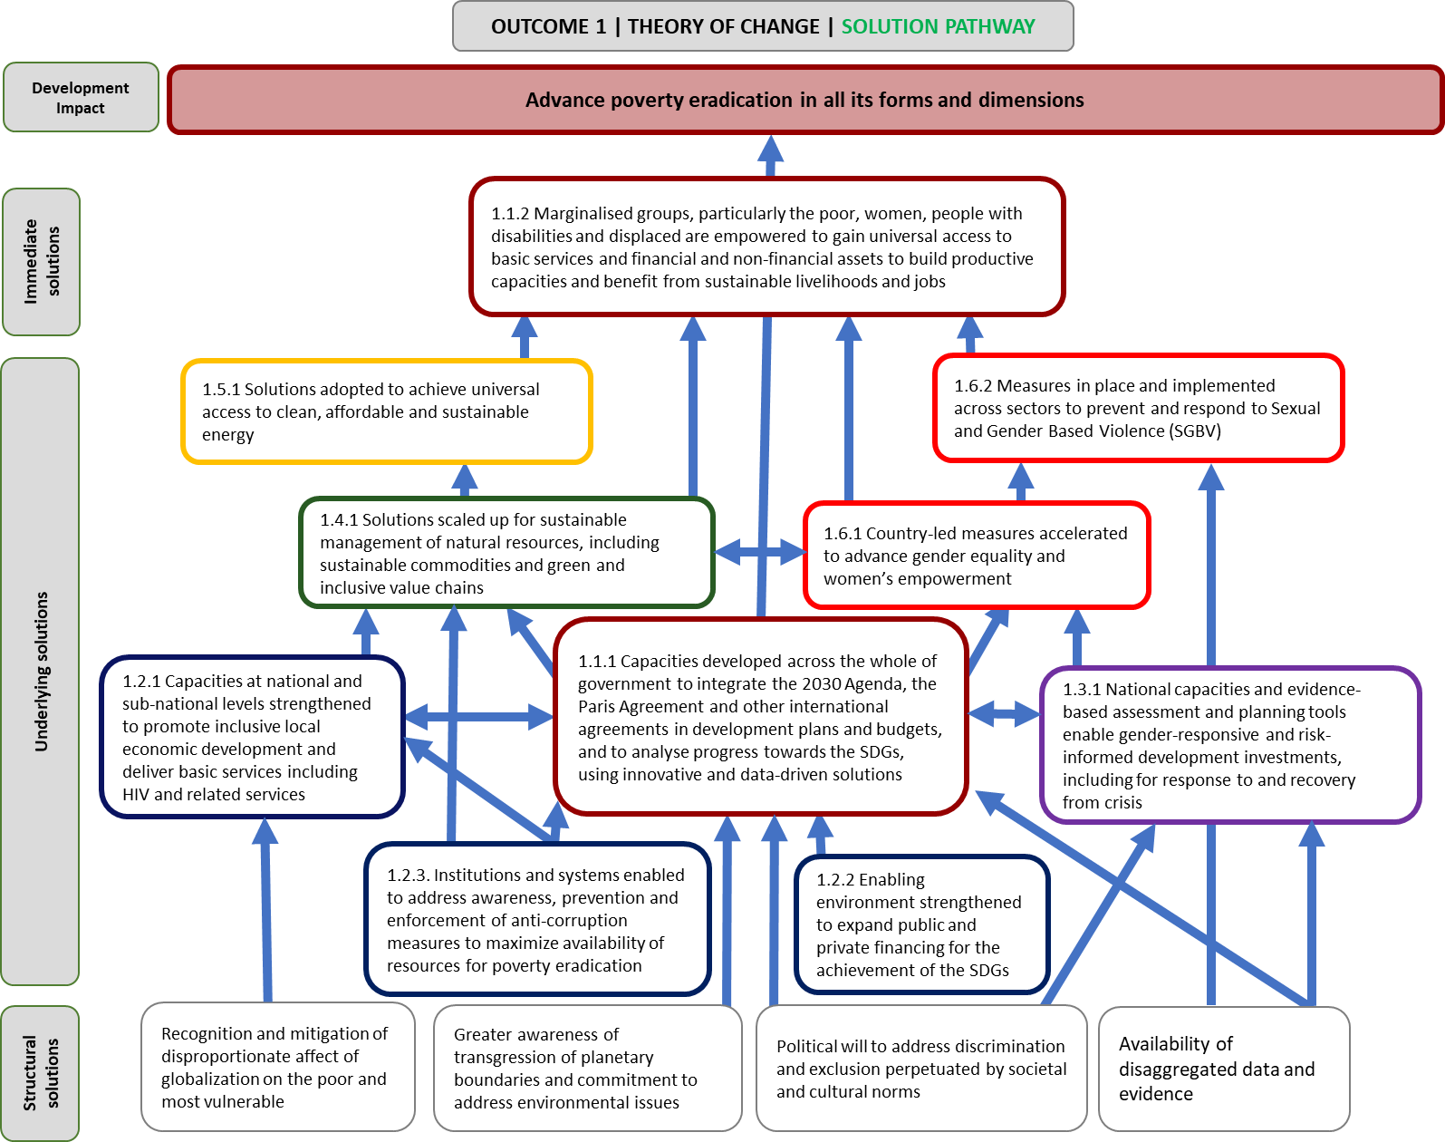

- Assumptions and risks, UNDP role, and primary partners
Assumptions | Risks
- Political will exists to address inequalities and multi-dimensional poverty, including resilience building to prevent people from falling back into poverty.  - Political support exists for addressing environmental degradation and the protection of natural resources in light of competing priorities for local and national financing.  - Gender equality and women’s empowerment are recognized as accelerators for progress on multi-dimensional poverty eradication.  - Multi-stakeholder engagement, including inclusion of marginalized populations improves decision-making.  - Emergent credible data and evidence on poverty will be utilised to inform policy and decision-making while overriding political lobbying (e.g. in favor of elite capture). | - Weak monitoring and accountability frameworks at the local, national, and international levels perpetuate poverty and inequalities.  - Unfair global economic governance and trade agreements entrench inequalities and lead to decline in decent jobs.  - Reduction in resources (domestic and international) dedicated to the SDG agenda and poverty alleviation efforts.  - Crises, planetary boundaries transgressions and demographic change (including migration) outpace the ability of governments to respond effectively.  - Corruption and vested interests/lobbying impedes integrated policy making, leads to policy incoherence, and decreases the availability of financial resources to support sustainable development.  - Political movements and ideologies, weak or biased legal frameworks and socio-cultural norms and values threaten basic principles of human rights, gender equality and non-discrimination.  - Elite capture, averse to pursuing multi-dimensional poverty approaches and integrated solutions to SDG/development challenges, and the participation of marginalized groups in decision-making.

UNDP role | Primary partners
- Supporting governments in strengthening the policy and regulatory environment and frameworks for implementation of the 2030 Agenda and the Paris Agreement.  - Pursuing multidimensional approaches to addressing poverty and inequalities.  - Developing and strengthening core government functions to improve service delivery targeted towards vulnerable population groups.  - Strengthening the rule of law and promoting human rights to achieve sustainable development and eradicate extreme poverty.  - Supporting the sustainable management of the environment and natural resources, including through policies and responses to reduce the impact of migration.  - Supporting private sector entities in aligning their operations and investments with sustainable development priorities.  - Strengthening national statistical capacities to produce disaggregated data to support implementation and monitoring of the SDGs.  - Supporting innovative development finance solutions to scale up domestic and international investments.  - Promoting political participation of marginalized populations with a focus on the role of women and young people.  - Increasing abilities of communities to manage risk and strengthen resilience to future crises induced by environmental, economic or social factors. | Government entities: Government agencies and public-sector institutions at national and sub-national/local levels are critical partners, particularly the Ministry of Planning and Finance, respective sectoral ministries, and the National Statistics Office. Regarding the implementation of the 2030 Agenda, in some countries, governments may have designated an institutional authority to coordinate the implementation and monitoring of the 2030 Agenda.  Civil society and academia: Civil society actors at national/local, regional and global levels have developed substantive capacities and influence on a range of development issues. Working with them will contribute to the effectiveness of development interventions, especially with respect to marginalized and vulnerable groups. This includes local communities and indigenous groups.  Partnerships with academia and think-tanks will build capacities and tools needed to advance thought leadership in the area of poverty impact and analysis.  United Nations system: For the eradication of poverty, partnership with UNICEF, UNFPA, UNAIDS, WHO, UNHCR, UN Women, ILO, WFP, UNEP, UN Habitat, UNIDO, Regional Economic Commissions, as well as the World Bank and IMF will be key.  Private sector: The private sector has a pivotal role in ensuring sustainable development and contributing to job creation, growth, sustainable commodities, and inclusive and green value chains.  UNDP is actively seeking relationships with foundations and philanthropic organizations from emerging countries where philanthropy is growing.  International financial institutions: UNDP has a large portfolio of work on financing for development (FfD): from supporting countries on how to access and programme environmental finance to working with aid providers and recipients to exchange knowledge and make development cooperation more effective, to carrying out research and policy. Main partners include IFIs such as the African Development Bank, Asian Development Bank, Council of Europe Development Bank, Development Bank of Latin American (CAF), Eurasian Development Bank, European Bank for Reconstruction and Development, European Investment Bank, Inter-American Development Bank, International Fund for Agricultural Development, Islamic Development Bank, and the World Bank Group. Vertical funds, in particular the Global Fund, the Global Environment Fund, the Green Climate Fund, are primary partners that facilitate access to financing.

- Outcome 2: Accelerate structural transformations for sustainable development

- Development challenges and causes
The disempowering nature of social, economic, and political exclusion results in ineffective, unaccountable, non-transparent institutions and processes that hamper the ability of a state to address persistent structural (vertical and horizontal) inequalities, fulfill internationally ratified human rights obligations, empower women and girls, and reduce gender inequality. Inequalities and exclusion are pervasive in environmental terms, for example: exclusion prevents fair and equitable access of rights to land and natural resources. Indigenous communities claim ownership of 65 per cent of global land but have formal titles for only 18 per cent, meaning they do not fully benefit from green economic growth. 2.5 billion people rely on wood or charcoal for their primary fuel source. Less than 20 per cent of the world's forests are certified as sustainably managed and the illegal logging trade is worth up to $15 billion US dollars annually.
The role of women in contributing toward structural transformation is challenged by multiple barriers. Women are unequally represented in decision making and have limited access to resources in economic (labour market, technology, finance), environmental, and political (constitutional, electoral, and parliamentary) processes, which has a negative effect on inclusive economic growth. While there have been important advances in women’s leadership, women make up only 7.2 per cent of Heads of State and 6.2 per cent Heads of Government. In addition to policies and legislation, patriarchal values are perpetuated by society, and attitudes and behaviors at the individual, interpersonal, community and national levels are affected by social norms that lead to exclusion and patterns of discrimination. A clear example of this are the levels of violence against women across the globe. It is estimated that 35 per cent of women worldwide have experienced physical and/or sexual violence at some point in their lives, and some national studies show that up to 70 per cent of women have experienced physical and/or sexual violence in their lifetime.
Governments are often unable to stay ahead of megatrends like globalization, urbanization and demographic changes, or climate change impacts, and frequently fail to take advantage of technological advances, and achieve energy efficiency or zero-carbon development. Low-emission development could help avoid a loss of $12 trillion US dollars, approximately 10 per cent of the global GDP, in the global economy by 2050. While the economies of many countries have been propelled by global trends and new technologies, more than 4 billion people still do not have access to the Internet. Moreover, fiscal constraints, limited financial flows and revenue leakage have prevented necessary investments from being made to systematically address insufficient or outdated infrastructure and services.
In such contexts, policy decisions are uninformed due to limited availability and/or weak analysis of data, as well as insufficient use of evidence. Governments lack the capacity to assess and/or prioritize policy alternatives, effectively target interventions (including social protection), and measure impacts. Furthermore, policies are not inclusive and are often gender-blind. Legal, policy and regulatory frameworks may not facilitate structural transformation and development plans do not clearly articulate sustainability objectives to overcome unsustainable natural resource management practices or include risk considerations to build resilience.
Public institutions often become an instrument of power in the hands of the existing elite, excluding certain groups from participating in decision making processes (particularly women) limiting the power of citizens to hold them accountable. Legal, policy and regulatory environments continue to undermine civic engagement and participation, leading to a shrinking civic space. Legitimacy of institutions and governments are diminished by perceptions of inequality and injustice. Weak institutions and processes, eroded social contracts, inequalities in access to power and resources are exacerbated by weak rule of law systems and an absence of independent institutions that uphold rule of law and/or human rights.

- Solutions and approaches
Under Outcome 2 of the Strategic Plan, UNDP will support countries as they accelerate structural transformations for sustainable development by: addressing inequalities and exclusion with a strong emphasis on reducing gender inequality and empowering women and girls; shifting to an environmentally sustainable growth model through zero-carbon development; strengthening governance that is inclusive, accountable and transparent, and using technologies and big data to improve public service. UNDP will help build resilience to shocks and crises (Outcome 3) by promoting transformations that contribute to disaster preparedness and risk reduction, climate change adaptation and mitigation, and conflict prevention. Additionally, the primary rationale for UNDP focus on structural transformations is that it is integral to eradicating poverty in all forms (Outcome 1), especially for those at risk of being left behind.

As a recognized leader in the provision of adaptation services—with a high standing on climate change, biodiversity loss, water pollution, land degradation and the control of persistent organic pollutants— UNDP is well-positioned to support structural transformation for sustainable development.
UNDP interventions under this outcome area will focus on the following:
Structural transformation for sustainable development will be accelerated: if participatory and decision-making processes and institutions are strengthened to promote inclusion, transparency and accountability; progressive social protection systems are developed; capacities of human rights institutions and systems are strengthened; capacities and will are strengthened and in place in order to promote economic diversification and green growth but not at the expense of the climate, clean energy and zero-carbon development; if women’s empowerment and gender-responsive legal and regulatory frameworks, policies and frameworks are further strengthened, and if technology and data are used appropriately to improve government services and functions and inform policy making; together these building blocks will help to create space for solutions to be explored, adopted, funded and implemented.

Development policies and plans that promote structural transformations, as strong drivers for change. These must be risk-informed, use data and evidence from diverse and reliable sources (including big data), and take into consideration gender-specific factors that affect men and women differently. Governments must be able to identify, and effectively target, those at most risk of being left behind in the design, implementation and monitoring of interventions, including social protection systems.

Political processes such as constitution-making, electoral cycles, and parliamentary processes, with participation from various segments of society (ethnic groups, class, gender, age, sexual orientation) and geographic areas (urban, peri-urban, rural), will allow for the voices of citizens to be heard and governments to be held accountable for policies and actions. Such processes can instigate change and transformation when governments are reluctant to do so or are protecting vested interests. Building a rule of law culture helps ensure that all citizens are treated equally, and human rights institutions protect and promote the rights of those who face discrimination, whether it is structural, systematic, individual or societal. Strong justice mechanisms must come into play so justice is not taken into individual hands and dissent does not grow, leading to political and/or social upheaval. Gender equality and the empowerment of women and girls is particularly important for structural transformation and has a profound effect on development outcomes.

As noted in the Strategic Plan evaluation, UNDP has strengthened processes for a more structured and transparent engagement of parliaments with governments and civil society.

Promotion of social protection systems and inclusive political processes are essential building blocks for achieving structural transformation. National, sub-national, and sectoral plans must embed climate resilient objectives, and development solutions must promote energy efficiency and zero-carbon development. Economic diversification and green growth strategies are critical for ensuring that development is sustainable, and economic activities are inclusive and include environmental and disaster and climate risk considerations. Regulatory and legal frameworks are effective instruments that need to be strengthened in order to protect natural resources and promote the equitable sharing of natural resource benefits (e.g. oil, gas, minerals). Enforcement of policies and regulatory instruments, combined with incentives for private sector engagement, are essential for achieving higher energy efficiency.

Taking advantage of, and leveraging, technological advancements as policy instruments to transform societies and economies. Technology and innovation, if used effectively, has the potential to facilitate and accelerate structural transformation for risk-informed sustainable development. Solutions may include the adoption of digital tools that dramatically improve the efficiency and effectiveness of, and access to, services (e.g. better assessing the demand and targeting of services or mobile banking in remote areas), and radically strengthen governance and accountability measures (e.g. voter registration, transparency and access to public information, citizen monitoring and reporting on corruption).

Technology-assisted solutions can help close the energy gap, and smart technologies for waste management can protect the environment. In addition, mobile phones, social media, drones and real-time satellite imagery can play an instrumental role in accelerating early warning, risk assessment and recovery systems following a disaster. Citizen monitoring platforms are transforming accountability on deforestation, while digital software has changed how we analyse, manage, and monitor land and seascapes. Taking advantage of such opportunities requires a long-term vision, strategic partnerships (e.g. collaboration with the information and communication technology [ICT] community), political will, context-specific capacities, and the adoption of a whole-of-system approach. Furthermore, significant investment is needed, with the right combination of private-public financing, from domestic and international sources.

Target groups
Under this outcome, particular emphasis will be placed on people who: 1) lack a say in decisions that affect them because they are under- or not represented in political processes and institutions; 2) are unable to access public services, including justice services, on an equal basis because of social, economic, or political exclusion; 3) whose quality of life and livelihoods are jeopardised or at risk due to climate change, disasters and environmental degradation; 4) live in, or are at risk of falling into, energy poverty; 5) do not have adequate access to technology, and 6) are at risk of displacement or detriment from unsustainable economic development.

Figure 4: Outcome 2 – Solution Pathway
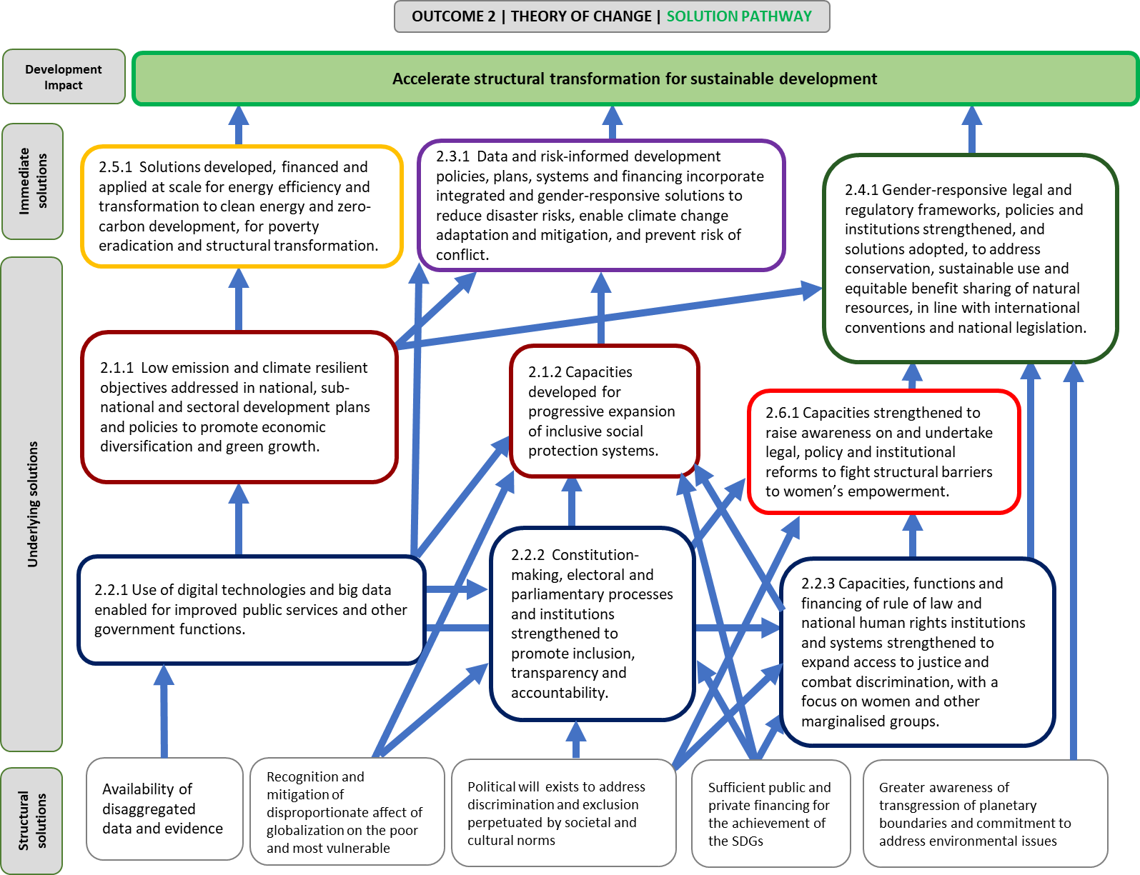

- Assumptions and risks, UNDP role, and primary partners
Assumptions | Risks
- Political commitment exists to implement reforms to policy, law and practices that hinder structural transformation (e.g. tackling persistent levels of poverty and inequality).  - Credible data and evidence will be utilized to inform social inclusion measures.  - Gender equality and women’s empowerment are recognized as accelerators for greater participation of women, girls and marginalized groups.  - Rule of law and national human rights institutions have the political space to operate in an independent manner to uphold the rights and address grievances, particularly of vulnerable groups.  - Respect for rule of law and human rights is recognized as fundamental to strengthening the foundation for peaceful, just and inclusive societies.  - Stakeholders are committed to make necessary investments towards clean energy and low-emission and climate/disaster resilient strategies with the aim of long-term zero-carbon development.  - Improvements in data generation and collection, and analysis will better inform policy formation: solutions will be evidence and data driven.  - Use of digital technologies reduce cost and increase the effectiveness of governments, enabling better services, functions, delivery (including improving public finance management). | - Political shifts (e.g. elections) and leadership changes bring instability and/or reversal of policies.  - Resistance to change due to vested economic interests.  - Systems improvements in identifying disadvantaged groups does not translate into more effective targeting or addressing of needs.  - Elites resist the broadening of representation, voice and power.  - People most left behind are detached from the political process and see little benefit in engaging.  - Shrinking of political and civic space, particularly for human rights defenders (including National Human Rights Institutions), may increase risk of reprisals and backlash.  - Lack of accountability and impunity for perpetrators of violence and abuse, due to weak rule of law and justice systems, contributes to a volatile security environment and increases risks of instability.  - High risk-perceptions prevalent among private investors (e.g., nature-based solutions not understood by investors), and challenges in identifying investment-ready projects.  - Crises, disasters, planetary boundaries transgressions and demographic change (including migration) outpace the ability of governments to respond effectively (sometimes temporarily).

UNDP role | Primary partners
Develop capacity of national and sub-national government counterparts (including providing technical expertise in areas like evidence-based planning and SDG alignment, or coordinating partnerships in areas outside core UNDP expertise areas).  Promote rights of women and marginalized groups and raise awareness about the rationale for greater gender equality.  Strengthen national capacities to better integrate human rights and gender equality into programming, national plans and policies.  Strengthen capacities of constitution making bodies (CMB), election management bodies (EMB), parliaments and parliamentarians to advance the 2030 Agenda including SDG 16.  Support countries to expand rule of law and human rights systems (e.g. support to access to justice programming), including a focus on inclusive and representative justice and security institutions, increased legal aid and awareness for marginalized populations and support to independent oversight mechanisms (e.g. NHRIs).  Provide technical expertise and develop capacity to design, access resources and implement initiatives that contribute to national low-emission and climate/disaster resilient priorities and transitions. Identify best practices in nature-based solutions, sustainable commodities and green growth.  Support the roll-out of smaller scale renewable energy generation projects, such as the expansion of solar home systems or mini-grids. Support governments in energy reform efforts, help link to relevant technical solutions providers, and put in place policies and systems to de-risk investments in renewable energy.  Support formulation of national plans and frameworks for digital transformation. Develop capacity to improve the adoption of ICTs in public service delivery. Develop local capacity for sustainable digital practices (through innovative partnerships, facilitating knowledge exchange, etc.). | Government entities: Governments, including national and sub-national Government entities (e.g. Ministry of Energy, Ministry of Environment, Ministry of Planning, Ministry of Economic Development) play the central role in facilitating structural transformations.  Accurate, relevant, and comprehensive data collection by statistics bodies, such as National Statistics Offices and supreme audit entities, are essential.  Favorable legal, regulatory, and policy settings, and consistent and competent application and enforcement by Rule of law and justice sector actors, human rights coordination functions and systems (including NHRIs) are critical.  Inclusive and well-capacitated parliaments, and parliamentarians, constitution making bodies, election management bodies are needed to ensure accountability for well-targeted and satisfactory regulation and service delivery  Civil society and academia: Significant expertise in thematic areas such as energy, ICT, and environmental matters often resides in the non-profit sector, which is vital for achieving structural transformation. Engagement with civil society and NGOs is essential to ensuring national ownership of the types of reform required to achieve transformations.  United Nations system: coordination of financial and technical assistance provision with UN organizations such as UNICEF, World Bank, ILO, UNAIDS, UNEP, UNFCCC, UNHCR, and other development partners is essential. Global UN partnership arrangements such as Global Focal Point Arrangement for Police, Justice and Corrections co-led with DPKO (OHCHR, UNODC, UNHCR, UN Women) and Global Alliance for SDG 16+ (UNDP, UNHCR, UNESCO, UNODC, the private sector, civil society and member states) are also effective instruments.  Private sector: Expertise and investment required to achieve structural transformation will only occur with the full participation of the private sector, including ICT and energy companies, and financial institutions.  In supporting countries to access and programme environmental finance, exchange knowledge and make development cooperation more effective. IFI partnerships will include both financial (direct and credit enhancements) and technical expertise sharing. This includes local private and public developers and financial institutions, telecommunications and financial technology companies, and SMEs/ICT for development.

- Outcome 3: Build resilience to shocks and crises

- Development challenges and causes
All countries have committed to achieving the goals and aspirations outlined in the 2030 Agenda, yet, some countries are disproportionally affected by shocks and stressors such as climate change, natural disasters, violent extremism, conflict, economic and financial volatility, epidemics, food insecurity and environmental degradation. The fallout of certain crises and stressors is determined by a country’s development choices and their capacity to prevent, adapt, and recover from events and/or proactively address underlying causes in an integrated manner.
Causes of crises are often linked and have a multiplying effect. Climate-related disasters have increased in number and magnitude, reversing development gains, aggravating fragile situations, and contributing to social upheaval. Rapid and unregulated urbanization is aggravating an already high-risk environment, while the loss of biodiversity and forest cover contributes to vulnerability. Over the past decade, more than 700,000 people lost their lives and over 1.4 million were injured as a result of natural disasters, with women disproportionately affected. Conflict, sectarian strife and political instability have been on the rise and more than 1.6 billion people live in fragile and/or conflict-affected settings. Half of those living in extreme poverty live in fragile settings—a number that will grow to 62 per cent by 2030 if not addressed. The latter poses serious challenges for countries with limited resources and capacities for basic service delivery and recovery efforts in the aftermath of disasters.
Around 244 million people are on the moveand 65 million have been forcibly displaced. Disasters and the effects of climate change have displaced more people than ever before. People living with chronic diseases are particularly vulnerable to shocks and crises because they are unable to access health care or social protection. Women and girls face a high risk of unwanted pregnancy, gender-based violence, sexually transmitted infections (STIs), and maternal mortality during humanitarian emergencies. One out of every 22 people living with HIV was affected by a humanitarian emergency in 2013 and unable to access life-saving treatment. Furthermore, major disease outbreaks result in severe economic losses due to the effect on livelihoods or decline in household incomes and national GDPs, as demonstrated by the Ebola outbreak in West Africa in 2014-2015. This outbreak, in particular, highlighted the importance of strengthening core government functions to build more resilient and sustainable health systems.
Promoting and increasing the number of sustainable jobs or livelihoods is a challenge, particularly in developing economies that face galloping demography and high levels of risk. Marginalized groups, including the poor, women and girls, young people, people living with HIV, people with disabilities and displaced people often find themselves without access to sustainable livelihood pathways. Women are frequently excluded from leadership posts or methods of participation in crisis prevention and recovery planning and action, which contributes to marginalization, exclusion and gender-based violence. Regulatory frameworks and institutions governing natural resources tend to be weak and not inclusive or gender responsive, leading to the disproportionate use and inequitable sharing of natural resources—all of which undermine resilience and recovery efforts. Weak governance systems and inadequate capacities to “risk-proof” development is a bottleneck for effective prevention, preparedness and recovery measures. A lack of investment in innovative, nature-based solutions and inadequate data to risk-inform development policies, plans and systems make people, communities, and nations more vulnerable to effects of shocks and crises. This, combined with scarce resources and increasing demands from larger populations, contributes to persistent and chronic vulnerabilities.
Rising inequalities and declining trust in public institutions reinforce the need to build and sustain peaceful, just, and inclusive societies. In post-crises contexts, limited access to social justice, redress mechanisms and security—plus weak capacities for integration, reconciliation, peaceful management of conflict, and limited resources—undermine the authority and legitimacy of state institutions. When governments are not able to deliver services and ensure stabilization, durable solutions cannot be ensured, making countries vulnerable to recurring crises.
- Solutions and approaches
Under Outcome 3 of the Strategic Plan, UNDP will strengthen resilience to shocks and crisis so countries can return to sustainable development pathways by increasing their abilities to take proactive measures to manage risk, prevent and/or respond more effectively to shocks and crises, and strengthen resilience to future crises. The UNDP commitment to the implementation of the 2030 Agenda, Paris Agreement, Sendai Framework, sustaining peace and prevention agenda, humanitarian-development-peace nexus, and the “New Way of Working” serve as guides under this outcome. The solutions pathways, as elaborated, build on the experience of UNDP in providing governance support to countries affected by conflict and, more specifically, supporting partner governments in addressing the most intractable structural causes of conflict.
When a crisis strikes, governments require integrated responses across sectors and at all levels (international, regional, national, sub-national and local) to restore core government functions and basic services. Strengthening national and sub-national risk management capacities, and addressing the underlying drivers of risk, are critical for strengthening a government’s ability to prevent and/or respond more effectively to future shocks and crises. UNDP’s support to recovery will foster rights-based developmental approaches that bring about transformational change, reduce underlying vulnerabilities and contribute to linkages with humanitarian and peacebuilding outcomes. UNDP will deploy integrated, multidimensional risk analysis and needs assessment tools to accompany our offer on enhancing national and local prevention and recovery capacities for resilient societies.
National and local systems will be more resilient to crises and shocks: if national capacities are strengthened in the areas of restoration of justice institutions, redress mechanisms and community security, reintegration, reconciliation, peaceful management of conflict, and prevention of violent extremism; if there is an increase in women’s leadership and participation in crisis prevention, recovery planning and action; and if evidence-based risk-informed prevention and preparedness assessments and planning tools and mechanisms are applied as appropriate. Resilience will manifest through core government functions and the restoration of inclusive basic services post-crisis; the adoption of innovative, nature-based and gender-responsive solutions; and reestablishment of energy access for crisis-affected populations.

UNDP interventions under this outcome area will focus on the following:

The quality of core government functions and ability to provide reliable and inclusive basic services as the foundation of the social contract between the people and state. In this regard, a responsive, effective and representative civil service, sound public finance and aid management system, accountable and fair justice and security mechanisms, strong coordinated actions at national and sub-national levels, and a well-functioning local government system are crucial variables in recovery processes and return to sustainable development pathways. Strengthening governance systems, institutions and mechanisms is central to building resilience to shocks and crises, enhancing civil society organization capacities, and securing mutual accountability.
As noted in the Strategic Plan evaluation, “UNDP support in countries affected by conflict has been crucial for the functioning of core governance institutions and consolidating stability and peace while transitioning to development. UNDP will continue to build on its ‘comparative advantage in supporting country efforts to restore the capacity of national and local governments to provide essential services after crises.”

Identifying and incorporating risk reduction is an integral part of development planning and implementation (Outcome 1) where access to contextual and applicable climate projections and risk information is critical. Disaggregated data for certain parameters (e.g. age, gender, disability or income), along with evidence on the effects of climate change, conflict and disasters on women and men, are important to tailor the design of interventions for specific needs. Strengthening national and sub-national capacities to carry out standardized and sex-disaggregated risk assessments, establish institutionalized damage and loss accounting systems, and apply risk information in inclusive national, local and sectoral planning processes are essential building blocks to the development solutions pathway.
Piloting innovative and transformative solutions within the recovery context, and exploring and adopting innovative funding and partnership strategies. The UNDG joint approach (‘MAPS) for SDG implementation is recognized as relevant and necessary in fragile contexts, building synergies and partnership across UN pillars for effective development solutions in complex settings. Building joint analytical approaches and stronger joint programming across humanitarian, development and peace actors, including towards collective outcomes in protracted crises is important to ensure development solutions are effective, efficient to prevent crises from escalation and accelerate a return to sustainable development pathways. Context-relevant collaborations with the private sector can be utilized for improved evidence-based policy and programming for prevention and recovery. Mobile phones, social media, drones and real-time satellite imagery can be instrumental for early warning, risk assessment, prevention, and accelerating recovery after disasters. To sustain peace, effective partnerships with UN peace and security actors need to be deepened across areas such as peacebuilding, rule of law, core government functions and transitions Innovative approaches should be applied to data gathering and analytical tools that measure economic effects and can help ensure sustainable and resilient recovery. Strengthening and diversifying sustainable livelihoods and supporting local economic revitalization fosters stabilization, builds durable solutions for economic recovery, and can prompt a return to sustainable development pathways that cater to the needs of men and women.
Ensuring that justice and redress mechanisms have a central role in social cohesion and are used when establishing conditions for stability and development. Empowering women, girls and communities to pursue peaceful and just dispute resolution, make legitimate demands on the state, and redress grievances (including gender-based violence) is critical. Equally important in crisis and post-crisis settings, is ensuring the provision of people-centered and gender-responsive security. While conflict creates challenges regarding the legitimacy and capacities of national counterparts, UNDP endeavors to support the ownership of national counterparts from the outset to avoid creating systems that may duplicate national structures. The Global Focal Point Assessments can facilitate joint programming on rule of law across the UN system.
As noted in the Strategic Plan evaluation, enhancing citizen security is an important component of UNDP rule of law initiatives, including community-oriented policing and the reduction of illicit arms in countries affected by conflict. These approaches are still central in the current Strategic Plan.

Supporting increased participation of women in all areas of peace and security decision-making processes is needed, not only as a right but because it significantly contributes to greater sustainability of peace through the establishment of new structures and institutions that reflect gender equality and social inclusion agendas. A recent study of 40 peace processes showed that women’s ability to influence negotiations increased the chances of agreements being reached, was positively correlated with greater implementation, and positively affected the sustainability of peace.
Supporting and strengthening local governance systems to be more representative and inclusive, incorporating the views of marginalized and vulnerable groups. This can prevent conflict from erupting or escalating and may lower incidences of violent extremism. Preventing violent extremism requires development solutions that address underlying causes related to economic, political and social grievances and/or exclusion, focus strongly on youth, and take into consideration the effects of climate change, disasters and other external shocks. In addition, solutions entail strengthening local mechanisms in a way that addresses gender differential requirements for early warning and conflict resolution, create space and strengthen capacities for dialogue, build consensus, address the underlying causes of recurring violence, build social cohesion, and resolve conflicts before they escalate. All of these results can enhance the prospects of a sustained development pathway.
Restoring access to energy in crisis/post-crisis situations is critical in the context of recovery since energy access is vital for safety and protection, and needed for homes, and health or evacuation facilities. When energy access is provided equitably to women and men they can build back better, especially when new livelihood opportunities are created. Recovery efforts should provide opportunities to strengthen preparedness and early warning measures for the energy sector by reducing the negative consequences on individuals and their assets following a shock or crisis. Energy solutions should be renewable, contribute to the reduction of greenhouse gases, and encourage the adoption of more sustainable development pathways (contributing to Outcome 2). The promotion of nature-based solutions and well-managed ecological infrastructure, such as forests and coastal ecosystems (e.g. mangroves or coral reefs), are essential for disaster risk reduction and climate adaptation as they protect assets and livelihoods against drought, floods, and storm surges.

Target groups
Under this outcome, particular emphasis will be placed on women and girls who are disproportionately affected by shocks and crises. Other groups include: 1) internally displaced persons—those forced from, or obliged to flee or leave their homes or places of habitual residence, in order to avoid the effects of armed conflict, situations of generalized violence, violations of human rights or natural or human-made disasters, and who have not crossed an internationally recognized state border; 2) people directly affected by natural disasters (as per the Sendai Framework) and who have suffered and injury, illness or other health issue, who were evacuated, displaced, relocated, or suffered direct damage to their livelihoods, economic, physical, social, cultural and environmental assets, and 3) people affected by conflict in “conflict-affected and high-risk areas,” which is an area experiencing armed conflict (international or domestic in character), widespread violence, or poses other risks to people (e.g. political instability or repression, institutional weakness, insecurity, collapse of civil infrastructure and widespread violence). Such areas are often characterized by widespread human rights abuses and violations of national or international law.

Figure 5: Outcome 3 – Solution Pathway
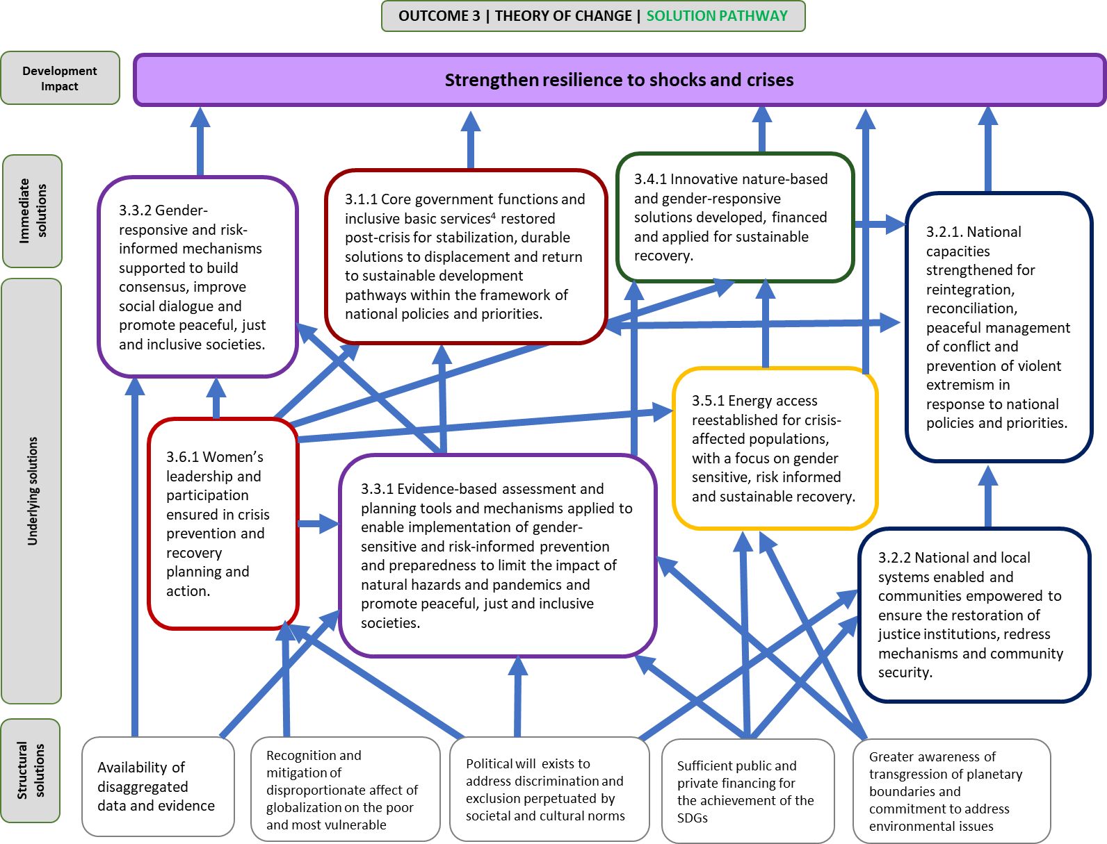
- Assumptions and risks, UNDP role, and primary partners
Assumptions | Risks
- Women’s active participation in, and leadership of, conflict prevention, disaster risk reduction, climate action, and recovery have multiplier effects on sustainable development.  - Political commitment provides fair and equal access to justice, redress and community security mechanisms, while rule of law and human rights institutions operate in an independent manner and uphold the rights/address grievances of people, particularly of marginalized and excluded groups.  - Restored or strengthened core government capacities, at all levels, deliver basic services to all segments of the population.  - Reintegration and reconciliation processes provide opportunities to peacefully address underlying conflict issues, underlying inequality issues, including gender inequality, improve relationships, build trust and public confidence in the state.  - Improving equitable access to energy leads to additional opportunities for all (including livelihoods, education and health), especially women/girls.  - Governments adopt “whole of society” approaches in resolving underlying grievance and causes of exclusion, and communities (which may have been excluded) are willing to engage in dialogue and reconciliation processes.  - Building capacities in assessment and planning leads to better preparedness and response mechanisms, thereby limiting the consequences of natural hazards and pandemics. | - Immediate needs (that result from shocks and crises) are prioritized by communities, governments and partners over investments in prevention and preparedness to future shocks and crisis.  - Weak and fragile systems are disproportionally affected by shocks and crises (e.g. political, economic and health), complicating and often slowing down recovery efforts.  - Security situations hamper access to high risk areas and vulnerable populations, and disrupts programme implementation, limiting effectiveness.  - Corruption at different stages of service delivery and policy implementation hinders equal access to resources and decision-making.  - Risk-related and sex and age disaggregated data is either not available, applicable to the context, or applied to inform investment and decisions over risk reduction and recovery.  - Recovery processes become less effective with increased risk for overlaps and gaps in provision of services, if development and humanitarian interventions are not aligned with national frameworks.  - Lack of accountability and impunity for perpetrators of violence and abuse increases risks of instability.  - Financing gaps and highly earmarked contributions do not meet the needs required to adequately respond to immediate onset or protracted crisis, and/or prioritize short term interventions, negatively affecting sustainability and effectiveness of recovery, resilience building, prevention, and peacebuilding interventions.  - Uncoordinated efforts by UN organisations and development partners, leading to duplication and contradictory interventions.

UNDP role
Support a “whole of government” approach in responding to crises and disasters, by assisting government efforts to restore core government functions and inclusive basic services.  Develop national and sub-national capacities to proactively assess and manage risk, prevent the harmful effects of, and strengthen resilience to, future shocks/crises, and ensure that the needs of vulnerable groups are met and no one is left behind.  Strengthen rule of law and security institutions so they are inclusive, legitimate, effective, and provide services that are accessible, especially in hard-to-reach or conflict-affected areas.  Strengthen national crisis prevention capacities and resilience-building, through a range of activities prior to, during, and in the aftermath of a crisis, including supporting climate change adaptation, improving early warning and risk reduction systems and post-crisis recovery efforts.  As a foundation for building resilience, strengthen inclusive and accountable governance, and promote gender equality and the empowerment of women and girls.  Strengthen national and local systems to ensure that displaced women, men and youth benefit from durable solutions, including jobs and livelihoods in crisis or post-crisis settings.  Strengthen frameworks for local economic revitalization in crisis-affected countries, including reintegration of displaced persons and former combatants. | Government entities: Governments, including national and sub-national Government entities (e.g. Ministry of Disaster Management, Ministry of National Planning, etc.) play a central role in managing risk, preventing and/or responding more effectively to shocks and crisis, and strengthening resilience to future crises.  Intergovernmental organizations: UNDP continues to work closely with intergovernmental organizations (such as the African Union, European Union, OECD, and others) to support an environment that addresses the challenges of fragility, foster policy dialogue and broaden national consultations on recovery and sustainable development priorities. Strengthen partnerships with International Network on Conflict and Fragility (INCAF) and the GPP.  Civil society and academia: UNDP will continue to work closely at all levels with civil society organizations, including International Federation of Red Cross and Red Crescent Societies (IFRC), National Red Cross and Red Crescent Societies (NRCRC), and other non-governmental organizations, in supporting prevention and preparedness, as well as recover from shocks.  United Nations system: UNDP, as Vice-Chair of the UNDG, will continue to foster strong partnerships with the UNDS and wider UN humanitarian, peace and security and human rights stakeholders. UNDP will promote joint approaches at the global, regional and country-level, as well as active engagement in the IASC, and scale up its engagement in UNDP flagship partnerships across the system, in particular with DPKO, DPA, PBSO, OCHA, OHCHR and UN Women through arrangements such as CADRI, the Global Focal Point arrangement on Rule of Law, Joint Programme on Conflict Prevention, Transitions Programme, UN-Energy Framework, Sustainable Energy for All, and others.  At the regional level, UNDP strengthens partnerships with Regional Economic Commissions, relying on their policy expertise and convening capacity to respond to economic shocks and sustainably implement the 2030 Agenda at the country levels.  UNDP works with Capacity for Disaster Reduction Initiative (CADRI) or the Global Preparedness Partnership (GPP) on disaster risk reduction and climate change adaptation.  As a cosponsor of UNAIDS, UNDP, the UNAIDS Secretariat, and other cosponsors implement UNDP accountabilities under the UNAIDS division of labour, Unified Budget Results and Accountability Framework.  Private sector: Strengthen private sector engagement on reporting on SDG 16 (as part of the Global Alliance) and the Private Sector Partnership for the Rule of Law and preparedness (e.g. on with on airport preparedness with Deutsche Post DHL Group).  International Financial Institutions: UNDP continues to strengthen its partnerships with a number of IFIs such as the World Bank and regional development banks, using their technical expertise and concessional financing resources to better enable resilient societies, especially in countries recovering from crisis resulting from protracted conflict/the sudden onset of violence and/or natural disasters. Specific partnerships arrangements include Post Disaster Needs Assessment and Recovery and Peacebuilding Assessments (World Bank and European Union) and Core Government Functions.  Independent oversight mechanisms: UNDP collaborates with National Human Rights Institutions in 90 countries and nurtures tripartite partnership with OHCHR and the Global Alliance of National Human Rights Institutions to strengthen support to NHRIs and global and regional networks of national human rights institutions.

DP/2017/38. UNDP Strategic Plan, 2018-2021.
Addis Ababa Action Agenda of the Third International Conference on Financing for Development; Paris Agreement; Sendai Framework for Disaster Risk Reduction; New Urban Agenda; Beijing Declaration and Platform for Action.
DP/2017/38, UNDP Strategic Plan, 2018-2021, p.3, Common chapter to the Strategic Plans of UNDP, UNICEF, UNFPA and UN Women.
Addis Ababa Action Agenda of the Third International Conference on Financing for Development; Paris Agreement; Sendai Framework for Disaster Risk Reduction; New Urban Agenda; Beijing Declaration and Platform for Action.
United Nations Development Programme, “UNDP Support to the Implementation of the 2030 Agenda for Sustainable Development”, Policy and Programme Brief, January 2016. Available from http://www.undp.org/content/undp/en/home/librarypage/sustainable-development-goals/strategy-undp-support-to-the-implementation-of-the-2030-agenda
DP/2017/33, Management response to the evaluation of the Strategic Plan, global programme and regional programmes, 2014-2017.
Executive Summary, in Evaluation of the UNDP Strategic Plan and Global and Regional Programmes(UNDP Independent Evaluation Office, August 2017), p. xii.
DP/2017/33, p.5, Recommendation 1.
DP/2017/38, p.3, Common chapter to the Strategic Plans of UNDP, UNICEF, UNFPA and UN Women.
A/72/684-E/2018/7, Repositioning the United Nations Development System to deliver on the 2030 Agenda: our promise for dignity, prosperity and peace on a healthy planet. Report of the Secretary-General, December 2017.
Includes youth, people with disabilities, people living with HIV and other traditionally marginalized groups, as relevant in each national context.
DP/2017/33, p.13. Recommendation 9.
Executive Summary, in Evaluation of the UNDP Strategic Plan and Global and Regional Programmes (UNDP Independent Evaluation Office, August 2017), p.17. Please see SS Mart for SDGs platform for country examples.
Executive Summary, in Evaluation of the UNDP Strategic Plan and Global and Regional Programmes (UNDP Independent Evaluation Office, August 2017), p.16.
United Nations Development Programme, SDG Accelerator and Bottleneck Assessment (New York, 2017).
United Nations Development Programme, UNDP Support to the Implementation of the Sustainable Development Goal 1: Poverty Reduction (New York, 2016).
Sabina Alkire and Gisela Robles, “Global Multidimensional Poverty Index 2017”. OPHI briefing 47. http://ophi.org.uk/global-multidimensional-poverty-index-2017/
Multi-dimensional poverty identifies deprivations at the household and individual level in health, education and standard of living, measured across 10 indicators: nutrition levels, child mortality, years of schooling, children enrolled in schools, access to cooking fuel, toilet access, water access, electricity access, flooring, and assets. It complements monetary measures of poverty by considering overlapping deprivations suffered by individuals at the same time. http://hdr.undp.org/en/content/multidimensional-poverty-index-mpi.
Oxfam International, “An economy that works for women”, briefing paper, March 2017.
Diana Mitlin and David Satterthwaite, Urban Poetry in the Global South: Scale and Nature (London and New York, Routledge, 2013). The World Bank estimates that, by 2035, most of the world’s extreme poor will be found in urban areas. http://blogs.worldbank.org/governance/governance/more-voices-mean-smarter-cities
Oxfam International, ‘Wealth: Having it All and Wanting More’, Issue Briefing, January 2015 (based on Credit Suisse Global Wealth Datebook 2014).
The Asian Development Bank has conducted studies that have shown how corruption can cost a country up to 17 per cent of its gross domestic product. https://www.un.org/press/en/2004/soccp301.doc.htm
International Labour Organization, Women at Work: Trends 2016 (Geneva, 2016), p.18.
United Nations Development Programme, Human Development Report 2016: Human Development for Everyone (New York, 2016).
In some countries, as many as, 1 out of 3 people fall back into poverty. See World Poverty Clock http://worldpoverty.io/
Stephane Hallegatte and others, Unbreakable: Building the Resilience of the Poor in the Face of Natural Disasters, Climate Change and Development Series(Washington. DC, the World Bank Group, 2017).
Stephane Hallegatte and others, Shock Waves: Managing the Impacts of Climate Change on Poverty, Climate Change and Development Series (Washington. DC, The World Bank/International Bank for Reconstruction and Development, 2016).
World Health Organization, World Health Report, 2010: Health systems financing the path to universal coverage (2010)
Executive Summary, in Evaluation of the UNDP Strategic Plan and Global and Regional Programmes, pp. xii (UNDP Independent Evaluation Office, August 2017).
Edward Royce, Poverty and Power: The Problem of Structural Inequality, 2nd ed. (New York, Rowman& Littlefield Publishers, 2015).
Ted Piccone, “Democracy, gender equality, and security”, Democracy and Security Dialogue Policy Brief Series, September 2017. https://www.brookings.edu/research/democracy-gender-equality-and-security/.
Rights and Resources Initiative, Who Owns the World’s Land? A global baseline of formally recognized indigenous and community land rights (Washington, D.C., 2015).
Nathanial Gronewold, “One Quarter of the World’s Population Lacks Access to Electricity”, Scientific American, 24 November2009. https://www.scientificamerican.com/article/electricity-gap-developing-countries-energy-wood-charcoal/
Forest Stewardship Council, “Facts & Figures”. https://us.fsc.org/en-us/what-we-do/facts-figures.
Laura Cabeza-García and others, “Gender Factors and Economic Growth: The Silent Revolution”, January 2018. www.mdpi.com/2071-1050/10/1/121/.
iKnow Politics, “Women’s Leadership”. http://iknowpolitics.org/en/focus-areas/6064.
World Health Organization, Department of Reproductive Health and Research, London School of Hygiene and Tropical Medicine, South African Medical Research Council, Global and regional estimates of Violence against Women: prevalence and health effects of intimate partner violence and non-partner sexual violence (Geneva, WHO, 2013), p.2.
UN Women, “Facts and Figures: Ending Violence against Women”, 2013. http://www.unwomen.org/en/what-we-do/ending-violence-against-women/facts-and-figures.
World Economic Forum, Global Risks Report 2017, 12th ed. (Geneva, 2017). http://www3.weforum.org/docs/GRR17_Report_web.pdf.
George T. Abed and Sanjeev Gupta, “The Economics of Corruption: An Overview”, in Governance, Corruption, & Economic Performance, George T. Abed and Sanjeev Gupta, eds. (International Monetary Fund, 2002). http://www.imf.org/external/pubs/nft/2002/govern/.
David Cortright and others, Governance for Peace: How Inclusive, Participatory, and Accountable Institutions Promote Peace and Prosperity (Cambridge University Press, 2017).
See Note 1 above.
Executive Summary, in Evaluation of the UNDP Strategic Plan and Global and Regional Programmes (UNDP Independent Evaluation Office, August 2017), p.12.
World Economic Forum, How the Fourth Industrial Revolution can help us prepare for the next natural disaster (Geneva, 2017). https://www.weforum.org/agenda/2017/09/preparing-for-the-next-natural-disaster-fourth-industrial-revolution/.
See for example the World Resources Institute’s Global Forest Watch www.globalforestwatch.org.
World Economic Forum, Harnessing the Fourth Industrial Revolution for the Earth (Geneva, 2017). http://www3.weforum.org/docs/WEF_Harnessing_the_4IR_for_the_Earth.pdf.
Sendai Framework for Disaster Risk Reduction 2015-2030, p.9. http://www.unisdr.org/we/inform/publications/43291.
OECD , States of Fragility 2016: Understanding Violence (Paris, 2016), p. 16. http://dx.doi.org/10.1787/9789264267213-en.
United Nations Department of Economic and Social Affairs, International Migration Report 2015 (New York, 2016). www.un.org/en/development/desa/population/migration/publications/migrationreport/docs/MigrationReport2015_Highlights.pdf
Office of the United Nations High Commissioner for Refugees (UNHCR), Global Trends: Forced Displacement in 2016(Geneva, 2017). http://www.unhcr.org/5943e8a34.pdf.
Joint United Nations Programme on HIV/AIDS (UNAIDS), HIV in Humanitarian Emergencies, Information Note (2015)
United Nations Development Programme, Socio-economic Impact of Ebola Virus Disease in Guinea, Liberia and Sierra Leone, Policy Notes Vol.1, Numbers 1-5 (2014).
United Nations Development Programme, Payments Programme for Ebola Response Workers: Cash at the Front Lines of a Health Crisis, Issue Brief (New York, May 2015).
Marginalized groups as identified in the Annex 1: Draft Integrated Results and Resource Framework of the UNDP Strategic Plan, 2018-2021. http://www.undp.org/content/undp/en/home/executive-board/documents-for-sessions/adv2017-special.html.
Executive Summary, in Evaluation of the UNDP Strategic Plan and Global and Regional Programmes (UNDP Independent Evaluation Office, August 2017).
United Nations Development Programme, Evaluation of the UNDP Strategic Plan and Global and Regional Programmes (Independent Evaluation Office, August 2017), p.16, 52.
Thania Paffenholz and others, Making Women Count-Not Just Counting Women: Assessing Women’s Inclusion and Influence on Peace Negotiations, Geneva: Inclusive Peace & Transition Initiative(The Graduate Institute of International and Development Studies) and UN Women(2016)

